**COVER PAGE**

**CYBER SHUJAA PROGRAM**

**WEEK 4 ASSIGNMENT REPORT :** BUSINESS INTELLIGENCE USING POWER BI

**STUDENT NAME:DOROTHY AWINO ONGONGA**

**STUDENT ID: CS-DA01-25075**

**POWER BI LINK:** [**https://mkuac-my.sharepoint.com/:u:/g/personal/dorothyawino_mylife_mku_ac_ke/EX6PHzAYmZFOp3xkXg0UHRcBC0d8-xrD_j7p_3u1FznD3A?e=iZ08Sd**](https://mkuac-my.sharepoint.com/:u:/g/personal/dorothyawino_mylife_mku_ac_ke/EX6PHzAYmZFOp3xkXg0UHRcBC0d8-xrD_j7p_3u1FznD3A?e=iZ08Sd)

**TABLE OF Contents**

**COVER PAGE** 1

CHAPTER 1:INTRODUCTION 1

**🌟** 1.1 Introduction to Business Intelligence with Power BI 1

1.2 🔍 Why Power BI? 1

CHAPTER 2 :TASK COMPLETION GUIDE 2

2.1 DATA TRANSFORMATION 2

2.2 DATA MODELLING 8

2.2.2⭐ Star Schema Model 9

2.2.3📊 Data Analysis Expressions (DAX) 9

2.2.3.1 CALCULATED COLUMNS 10

: CREATING KEY MEASURES 12

2.3: DASHBOARD CREATION 16

2.3.1.CHART CREATION 16

2.3.3: ADDING KEY PERFORMANCE INDICATORS 18

>CREATING DASHBOARD 2 21

3.0:CONCLUSION 25

# 

# **CHAPTER 1:INTRODUCTION**

**🌟 1.1 Introduction to Business Intelligence with Power BI**

In today’s data-driven world, organizations collect massive amounts of data from various sources—sales transactions, customer interactions, social media, and more. However, raw data alone is not useful unless it is transformed into actionable insights. That’s where **Business Intelligence (BI)** comes in.

**Business Intelligence** refers to the technologies, applications, and practices used to collect, integrate, analyze, and present business data. Its goal is to support better business decision-making.

One of the most popular and user-friendly BI tools available today is **Power BI**, developed by Microsoft. Power BI allows users—from beginners to experts—to turn data into interactive visual dashboards and reports, helping organizations uncover trends, monitor performance, and make data-driven decisions.

### 1.2 🔍 Why Power BI?

* **Easy to Use**: With drag-and-drop features and pre-built visualizations, Power BI is beginner-friendly.
* **Powerful Data Modeling**: Connect to multiple data sources (Excel, databases, cloud services) and transform data with Power Query.
* **Interactive Dashboards**: Create dynamic visuals that allow for deep exploration of business metrics.
* **Cloud Sharing**: Share reports and dashboards online for team collaboration and real-time updates.

1.3 📊 What You Can Do with Power BI

* Track **sales performance** across different regions.
* Visualize **customer behavior** and preferences.
* Monitor **financial KPIs** like revenue, profit, and expenses.
* Forecast **trends** using historical data.
* Identify **bottlenecks** and opportunities for growth.

Power BI empowers both individuals and enterprises to make **informed, strategic decisions** by bringing data to life. Whether you're a student, analyst, manager, or business owner, learning Power BI opens doors to smarter data analysis and better business outcomes.

# **CHAPTER 2 :TASK COMPLETION GUIDE**

### 2.1 DATA TRANSFORMATION

**Data transformation** in Power Query refers to the process of cleaning, shaping, and restructuring raw data into a format suitable for analysis. This step is essential to ensure the data is accurate, consistent, and ready for reporting in Power BI.

Using Power Query’s intuitive interface, you can perform tasks like:

* Removing or filtering rows
* Splitting or merging columns
* Changing data types
* Renaming columns
* Pivoting/unpivoting data
* Handling missing or duplicate values

Each transformation step is recorded automatically, allowing you to trace or modify your workflow anytime.

📁 **The data used in this project was downloaded from** [***Codebasics***](https://www.codebasics.io/)**-**[**Master Data Analyst Course online from Scratch | Codebasics**](https://codebasics.io/courses?page=2) **as part of their Resume Projects series. All credit goes to Codebasics for providing practical learning resources.**

**PROBLEM STATEMENT**

AtliQ Grands owns multiple five-star hotels across India. They have been in the hospitality industry for the past 20 years. Due to strategic moves from other competitors and ineffective decision-making in management, AtliQ Grands are losing its market share and revenue in the luxury/business hotels category. As a strategic move, the managing director of AtliQ Grands wanted to incorporate “Business and Data Intelligence” to regain their market share and revenue. However, they do not have an in-house data analytics team to provide them with these insights.  
  
Their revenue management team had decided to hire a 3rd party service provider to provide them with insights from their historical data.

**Task:**    
  
You are a data analyst who has been provided with sample data and a mock-up dashboard to work on the following task. You can download all relevant documents from the download section.

1. Create the metrics according to the metric list.
2. Create a dashboard according to the mock-up provided by stakeholders.
3. Create relevant insights that are not provided in the metric list/mock-up dashboard.

The file contains all the meta information regarding the columns described in the CSV files provided 5 CSV files:

1. dim_date

2. dim_hotels

3. dim_rooms

4. fact_aggregated_bookings

5. fact_bookings

**Column Description for dim_date:**

1. date: This column represents the dates present in May, June and July.

2. mmm yy: This column represents the date in the format of mmm yy (monthname year).

3. week no: This column represents the unique week number for that particular date.

4. day_type: This column represents whether the given day is Weekend or Weekeday.

**Column Description for dim_hotels:**

1. property_id: This column represents the Unique ID for each of the hotels.

2. property_name: This column represents the name of each hotel.

3. category: This column determines which class[Luxury, Business] a particular hotel/property belongs to.

4. city: This column represents where the particular hotel/property resides in.

**Column Description for dim_rooms:**

1. room_id: This column represents the type of room[RT1, RT2, RT3, RT4] in a hotel.

2. room_class: This column represents to which class[Standard, Elite, Premium, Presidential] particular room type belongs.

**Column Description for fact_aggregated_bookings:**

1. property_id: This column represents the Unique ID for each of the hotels.

2. check_in_date: This column represents all the check_in_dates of the customers.

3. room_category: This column represents the type of room[RT1, RT2, RT3, RT4] in a hotel.

4. successful_bookings: This column represents all the successful room bookings that happen for a particular room type in that hotel on that particular date.

5. capacity: This column represents the maximum count of rooms available for a particular room type in that hotel on that particular date.

**Column Description for fact_bookings:**

1. booking_id: This column represents the Unique Booking ID for each customer when they booked their rooms.

2. property_id: This column represents the Unique ID for each of the hotels

3. booking_date: This column represents the date on which the customer booked their rooms.

4. check_in_date: This column represents the date on which the customer check-in(entered) at the hotel.

5. check_out_date: This column represents the date on which the customer check-out(left) of the hotel.

6. no_guests: This column represents the number of guests who stayed in a particular room in that hotel.

7. room_category: This column represents the type of room[RT1, RT2, RT3, RT4] in a hotel.

8. booking_platform: This column represents in which way the customer booked his room

9. ratings_given: This column represents the ratings given by the customer for hotel services.

10. booking_status: This column represents whether the customer cancelled his booking[Cancelled], successfully stayed in the hotel[Checked Out] or booked his room but not stayed in the hotel[No show].

11. revenue_generated: This column represents the amount of money generated by the hotel from a particular customer.

12. revenue_realized: This column represents the final amount of money that goes to the hotel based on booking status. If the booking status is cancelled, then 40% of the revenue generated is deducted and the remaining is refunded to the customer. If the booking status is Checked Out/No show, then full revenue generated will goes to hotels.

To load data from a folder named **"Input Files"** (located in **Downloads**), go to **Power BI Desktop**, click **"Get Data" > "Folder">Connect**, then browse to Downloads\Input Files and click **OK**. Power BI will show a preview of the files. Click **"Transform Data"** to open the **Power Query Editor**.In Power Query, you’ll see a table listing the files in the folder. To preserve the original data, **right-click** on the query named **"Input Files"** in the **Queries pane** and select **"Duplicate"**. This creates a copy of the query that you can clean or modify while keeping the original unchanged

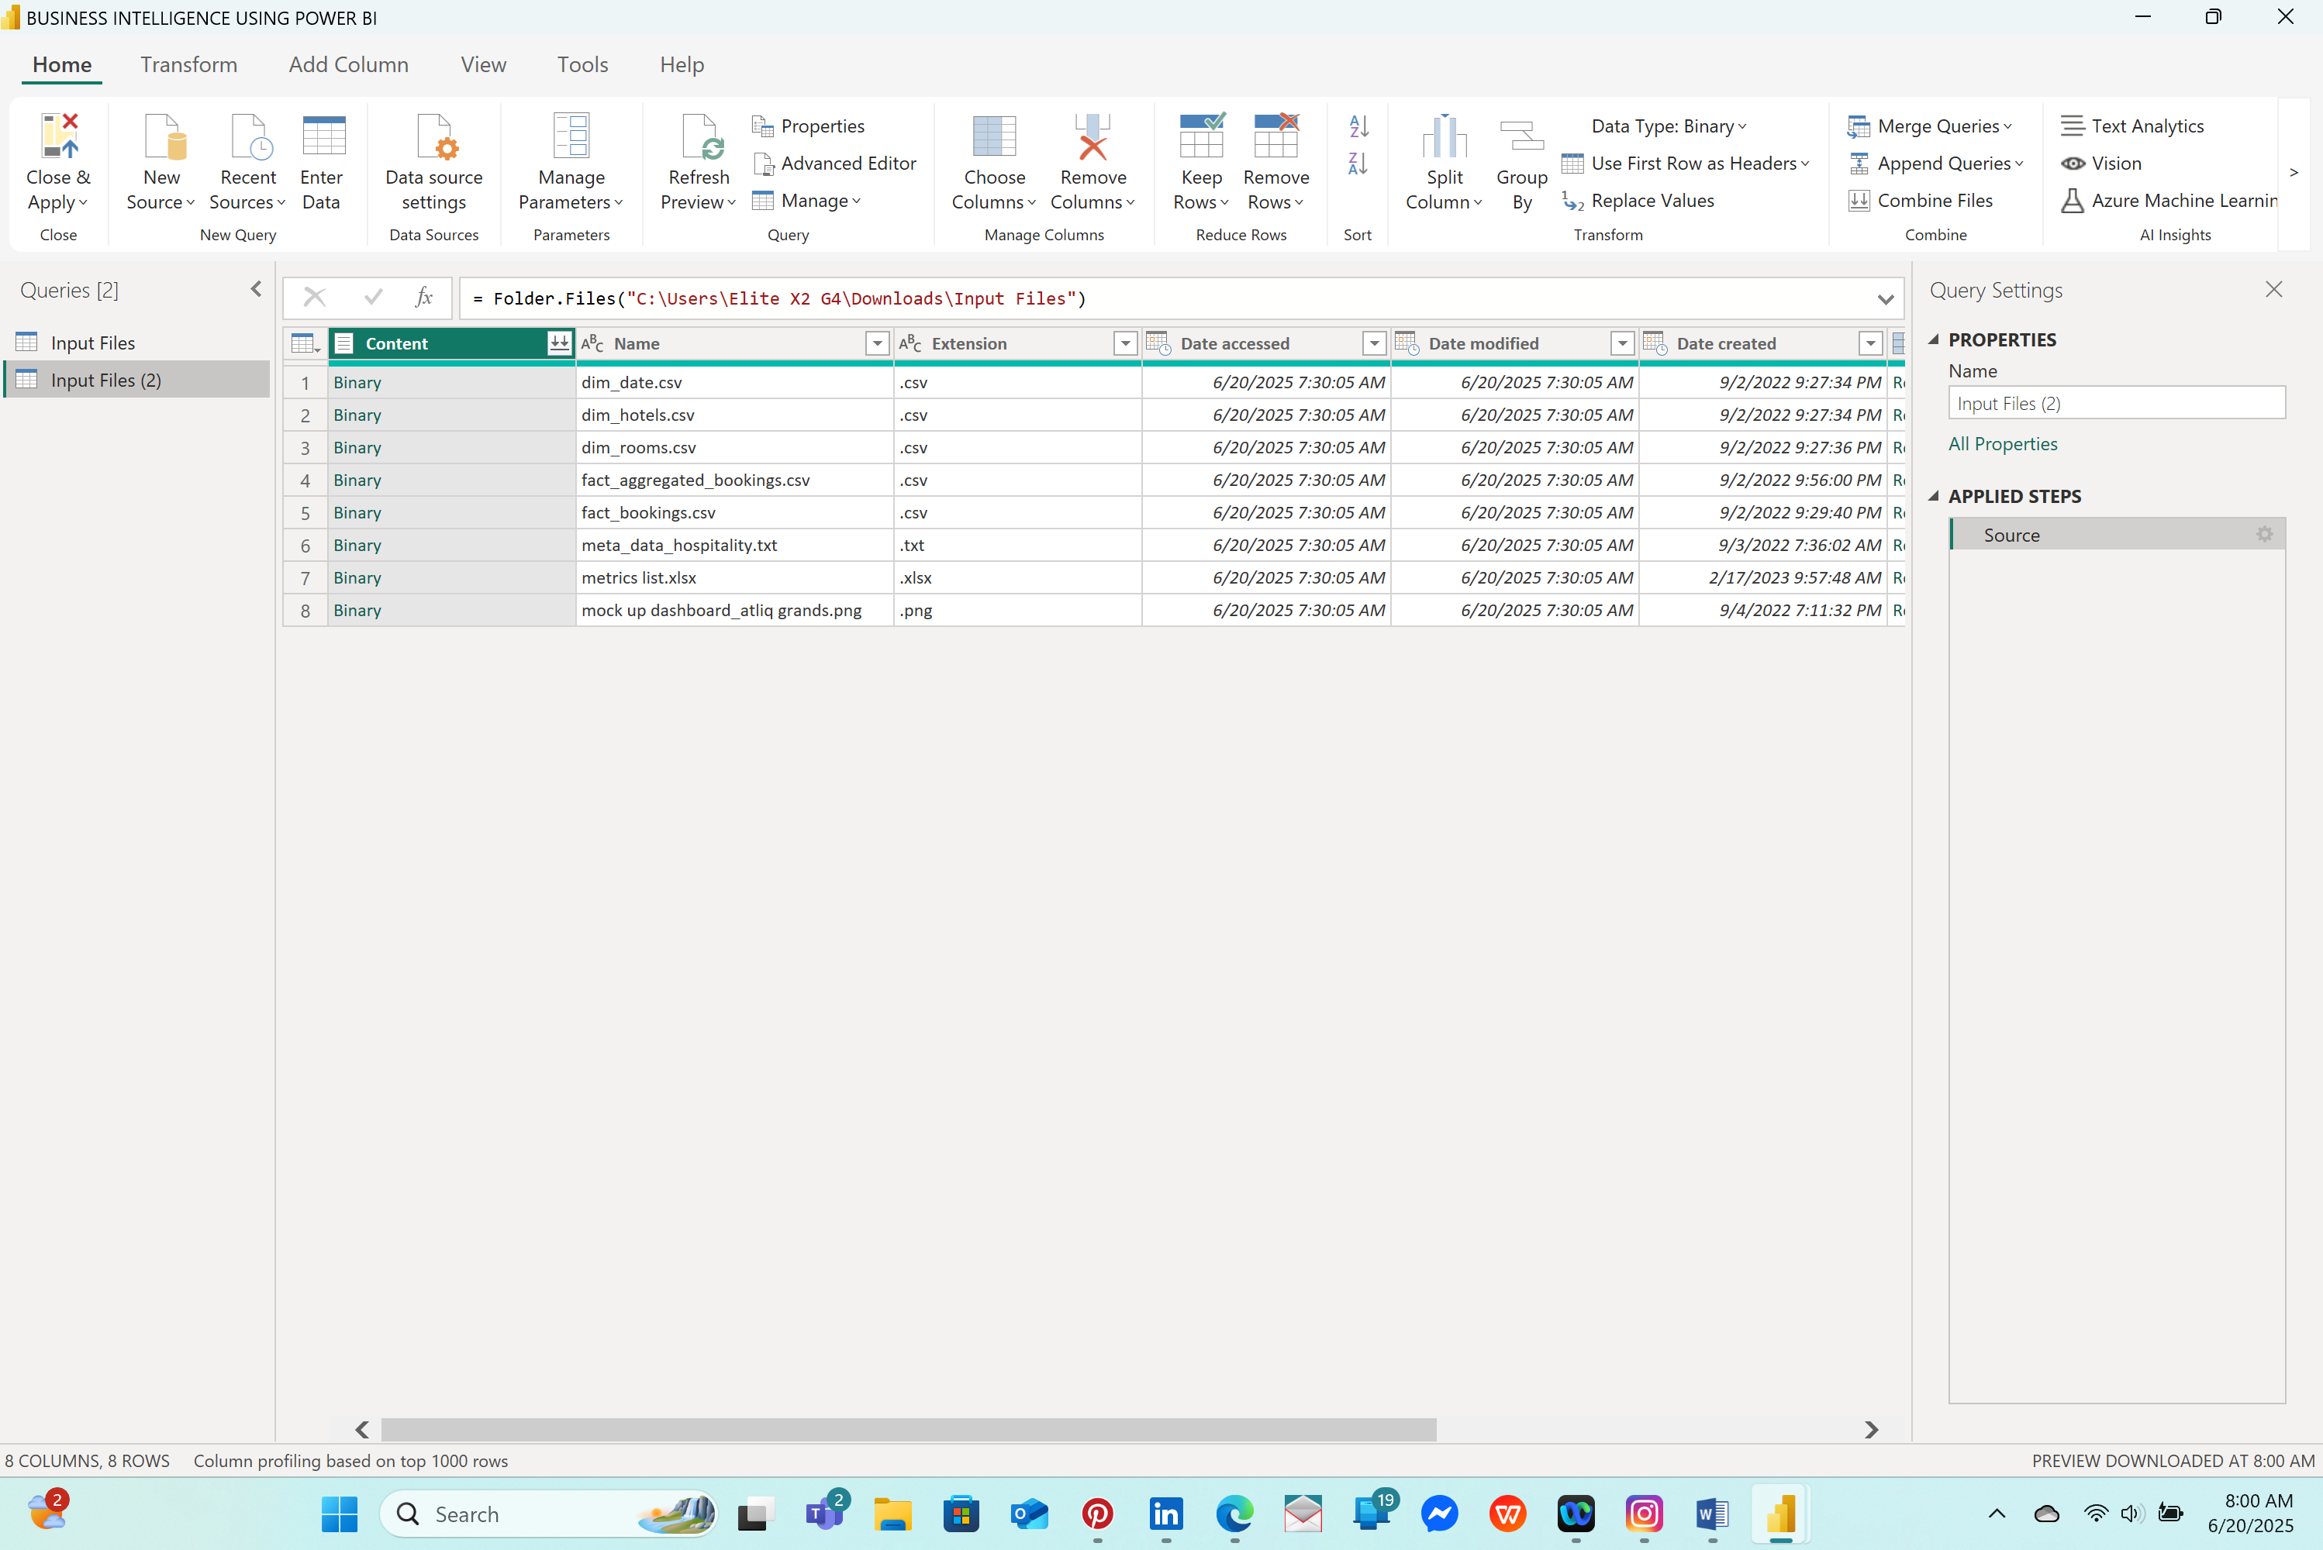

GO To **Input Files** click Binary( dim_date.csv) to expand the file, which has dates categorized into two groups, **weekday** and **weekend,** and **RENAME** it as **dim_date. DUPLICATE Input Files (2)** a couple of times

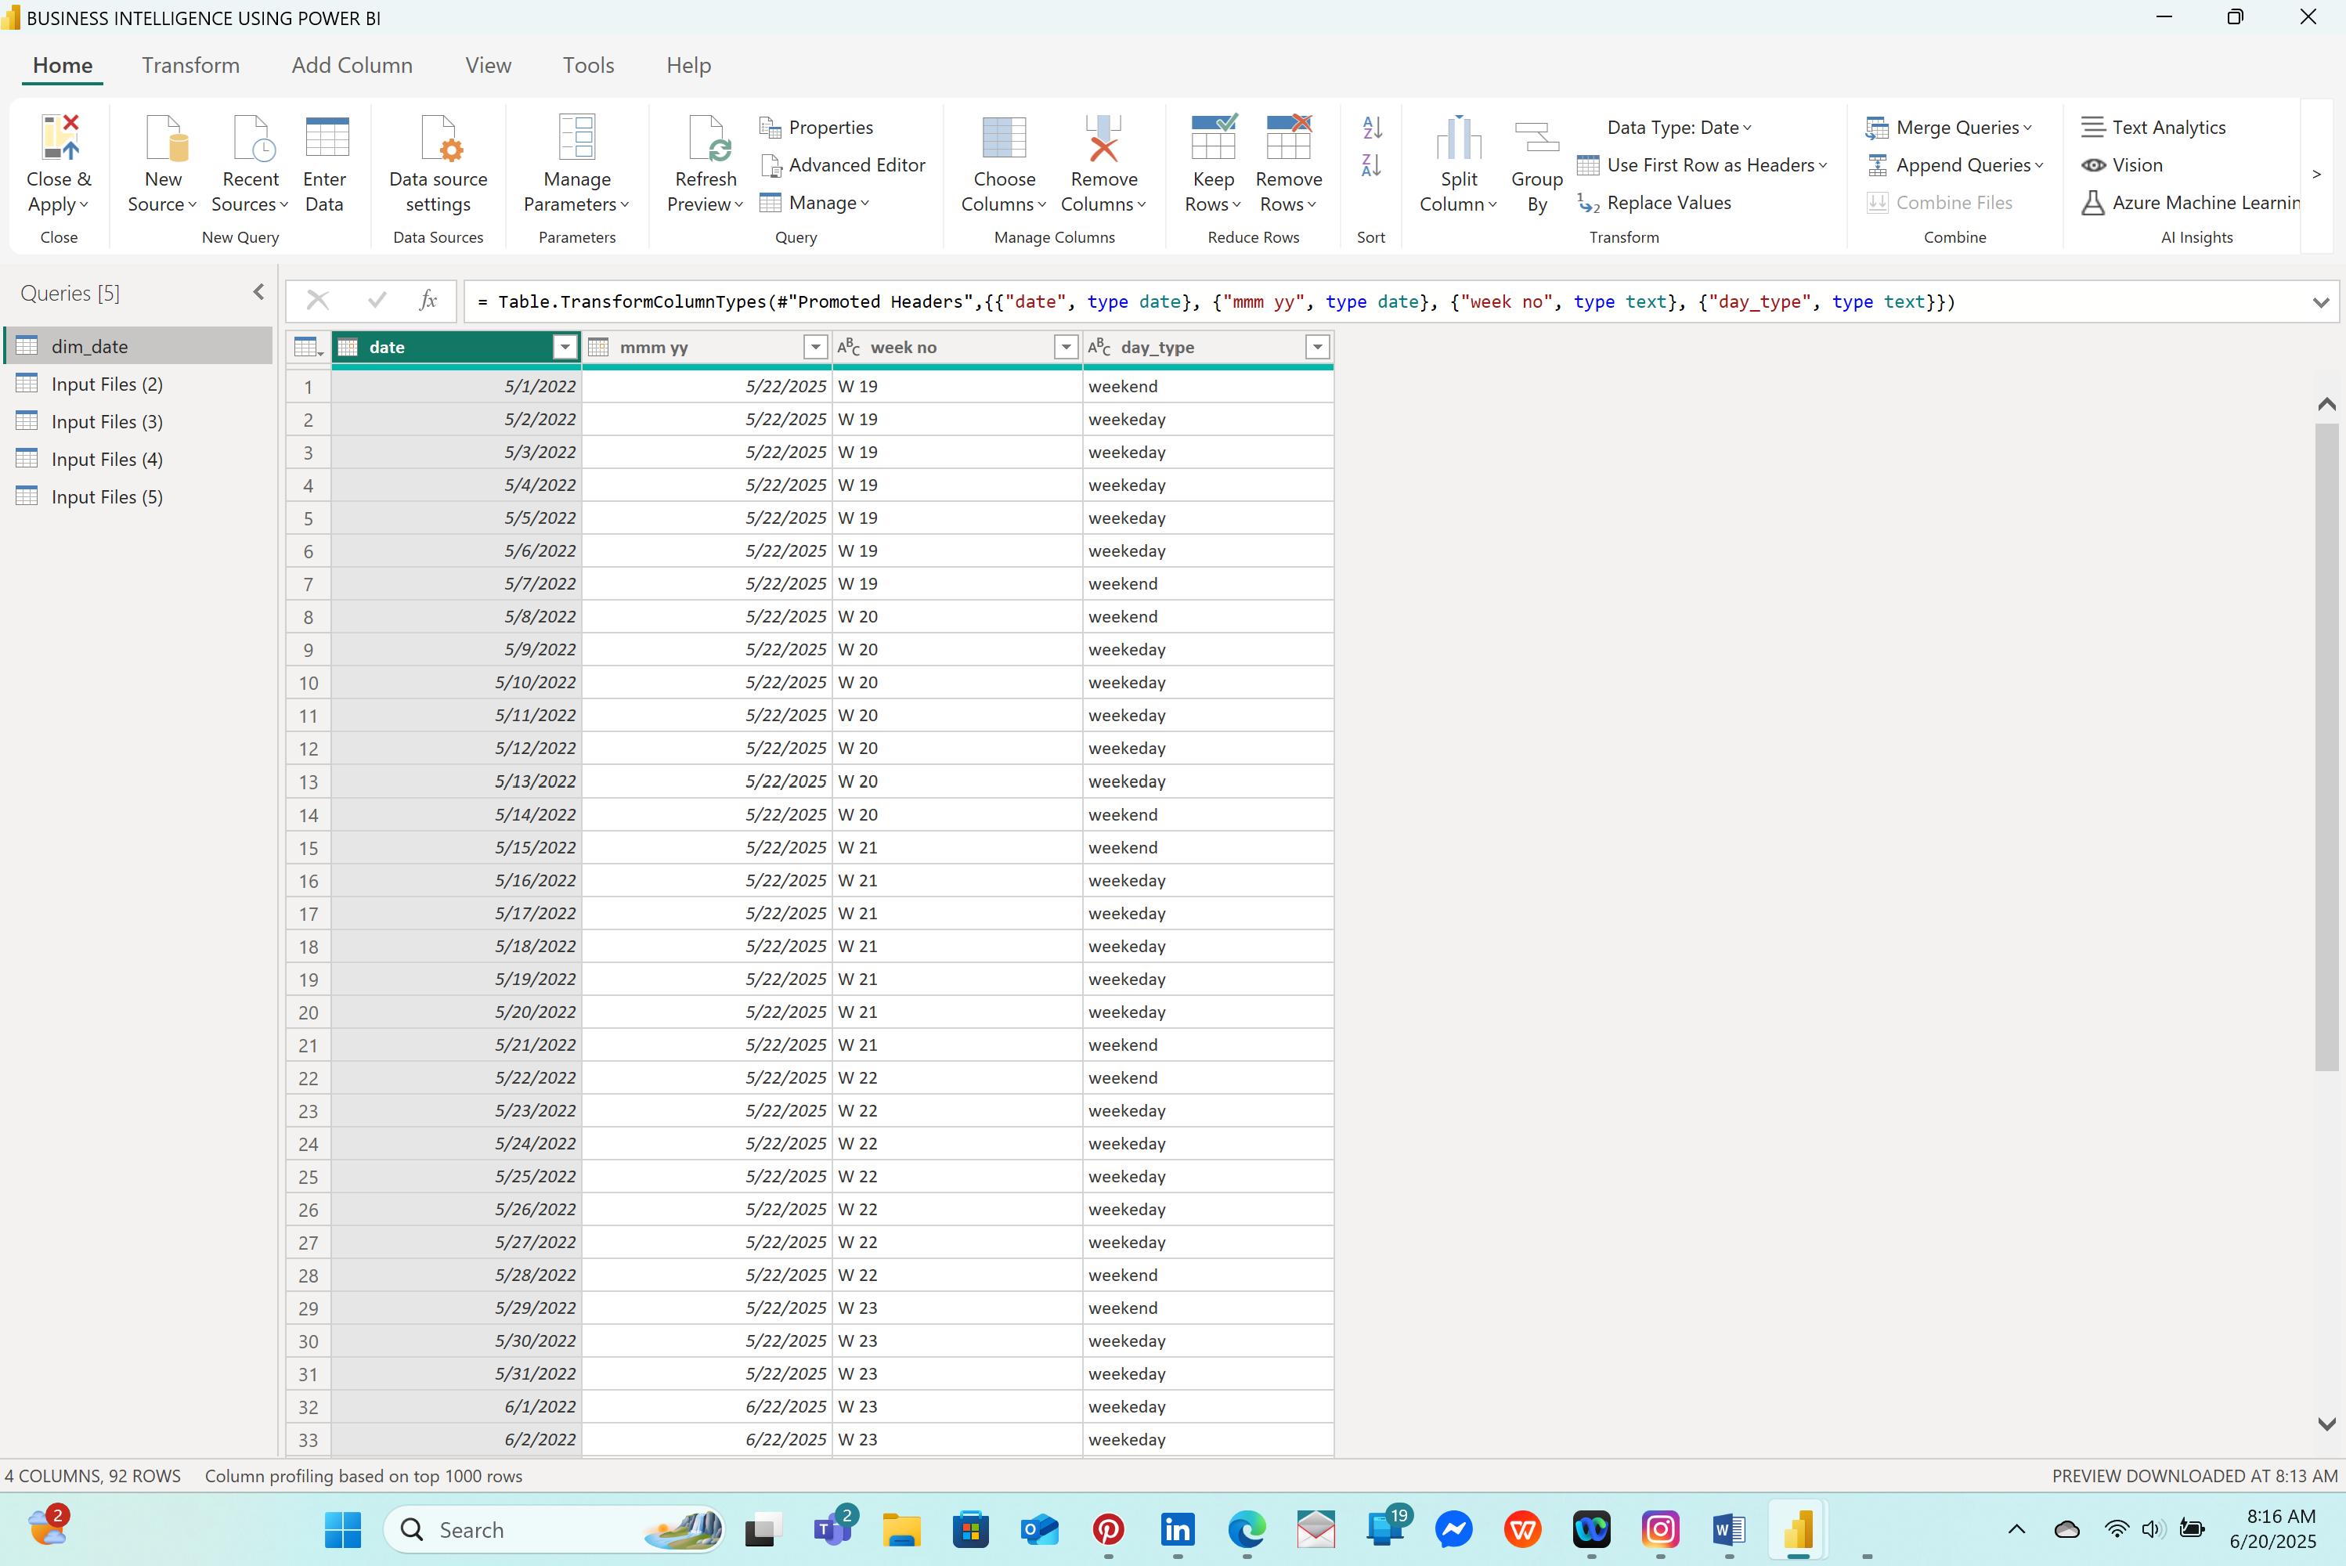

RENAME **INPUT 2** as **dim_hotels**, **INPUT 3** as **dim_rooms,** and change the **COLUMN 1** and **COLUMN 2** on the dim_rooms table to **room_id** and **room_class,** respectively, by clicking the “**use first row as header** " option on, **INPUT 4** as **fact_aggregated_bookings,** and **INPUT 5** as **fact_bookings.**

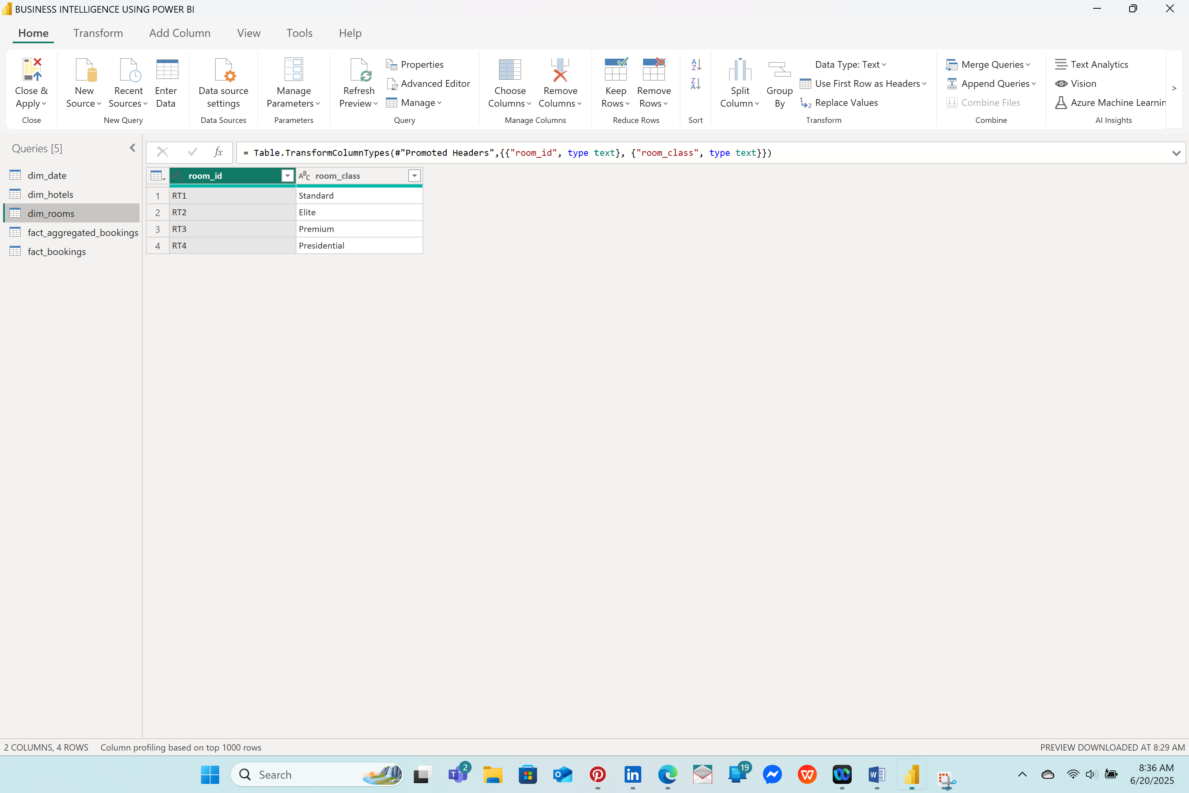

In the hotel business, Fridays and Saturdays are considered weekends, but in the dim_date table, weekends are Saturday and Sunday. The **day_type** column is not useful, so I deleted it by clicking “**Remove”** on the drop-down menu

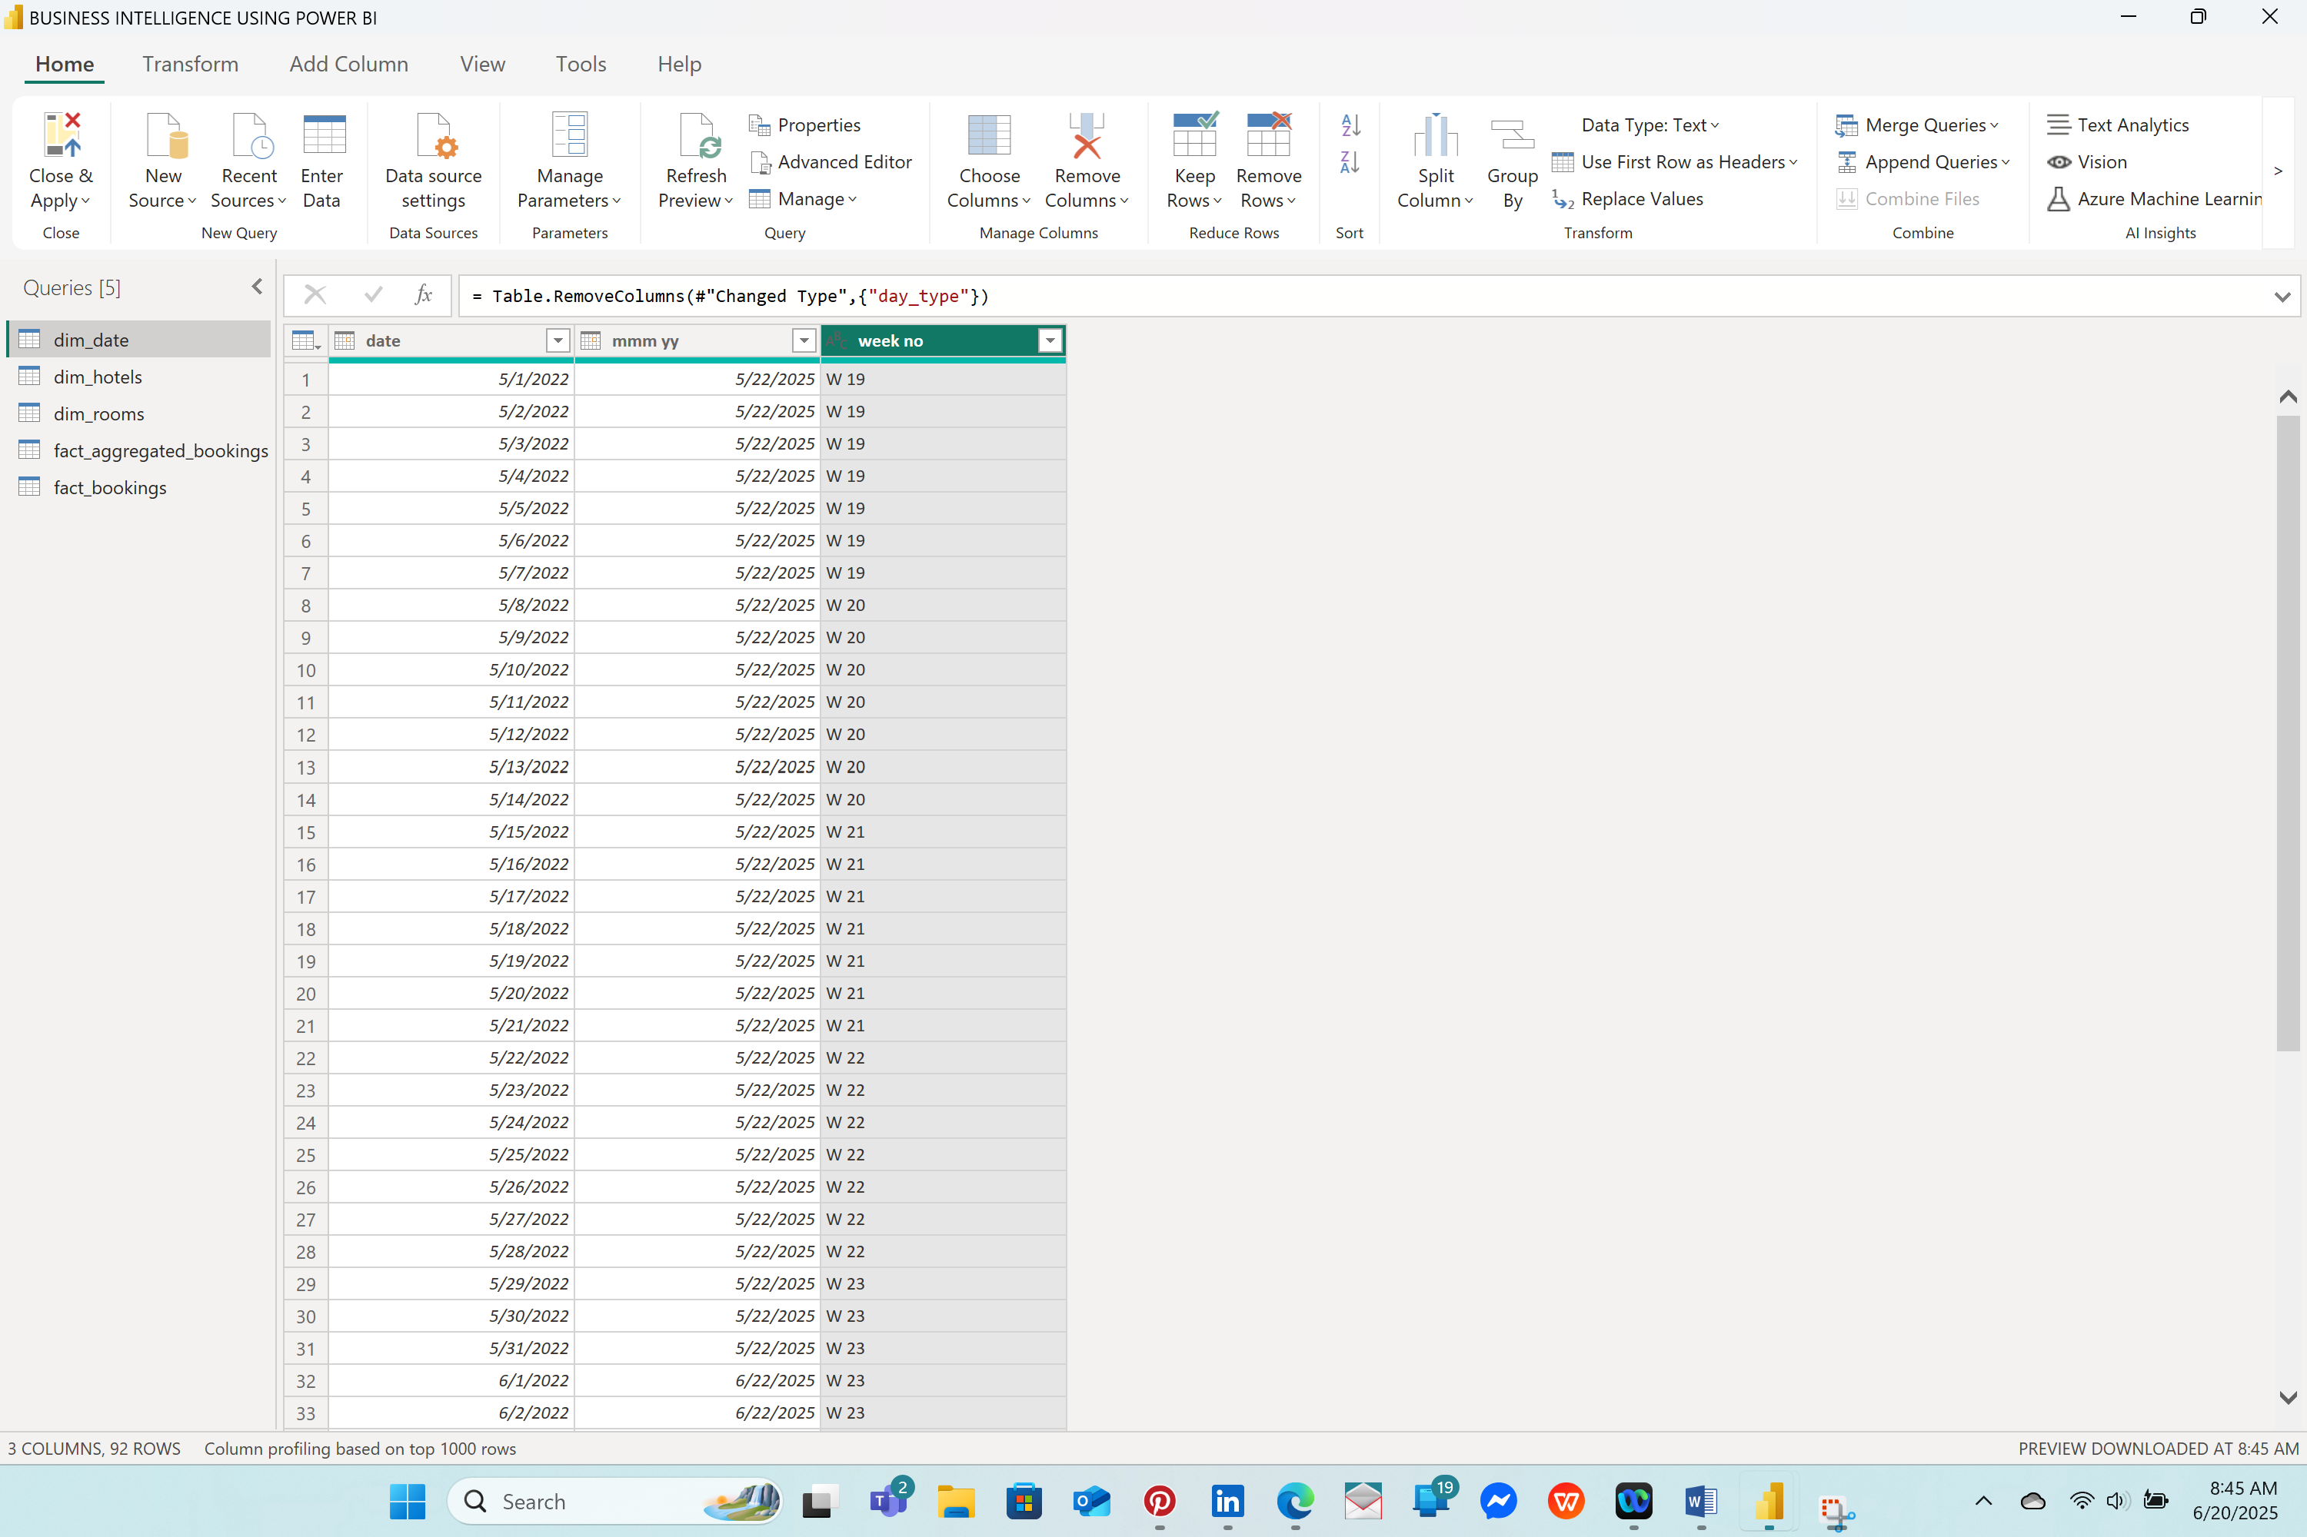

**>ADDING DAY TYPES**

DAY NAME = FORMAT('dim_date'[date],"dddd")

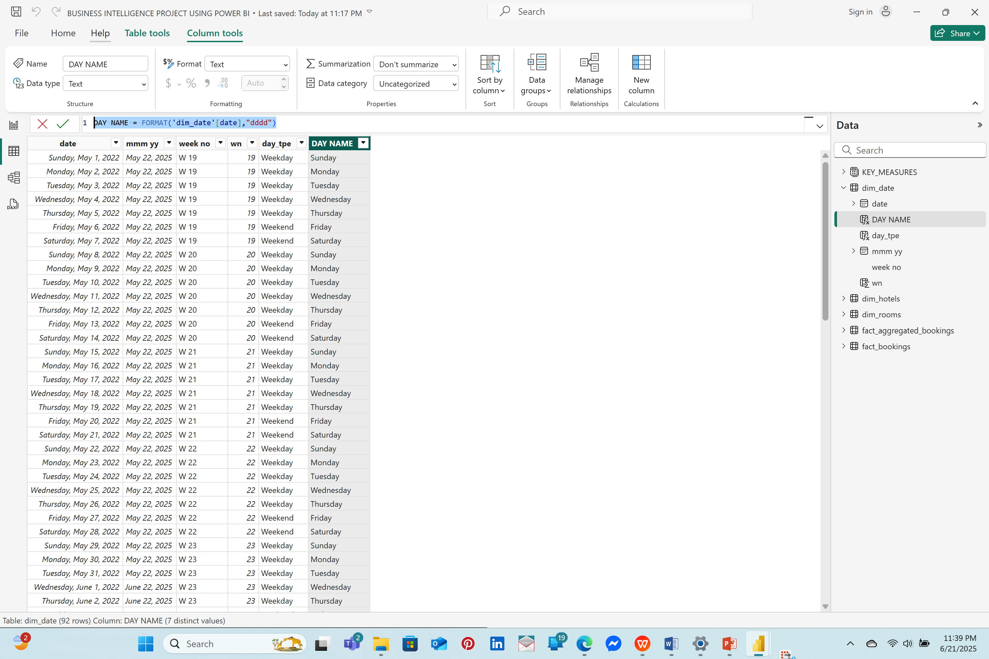

Next Click on the “**CLOSE & APPLY**” Under “**HOME”** to conclude the steps under POWER QUERY step of DATA TRANSFORMATION

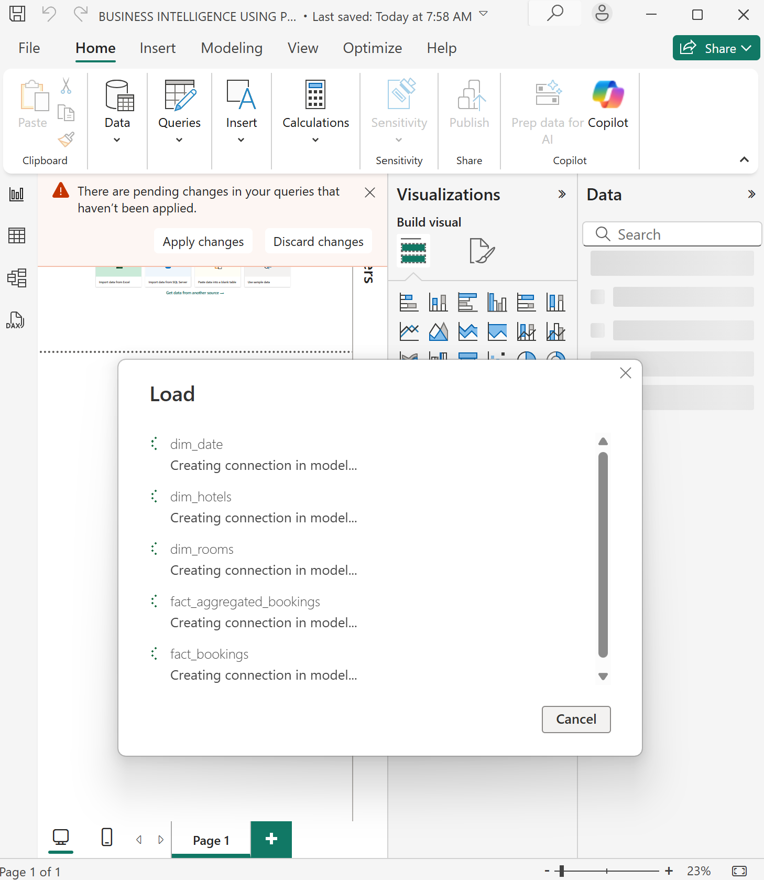

### 2.2 DATA MODELLING

#### 2.2.1🧩 Data Modeling in Power BI

**Data modeling** in Power BI is the process of connecting and organizing multiple tables using relationships to create a structured and meaningful data model. It allows you to link data from different sources using keys (like IDs) so you can analyze them together seamlessly.

In the **Model view**, you can:

* Define **relationships** between tables (one-to-many, many-to-one)
* Create **calculated columns** and **measures** using DAX (Data Analysis Expressions)
* Set **data types** and **table hierarchies**

A well-designed data model ensures accurate calculations, improves performance, and makes reporting more intuitive and efficient.

## 2.2.2⭐ Star Schema Model

The **Star Schema** is a widely adopted data modeling technique used in business intelligence to optimize data for reporting and analysis. It features a **central fact table** containing key business metrics (such as sales, profit, or transactions), which is directly linked to multiple **dimension tables** that provide contextual information (such as time, product, customer, or region).This structure resembles a star, with the fact table at the center and dimensions radiating outward. The star schema simplifies complex data relationships, enhances query performance, and supports intuitive, self-service analytics. It is especially effective in Power BI for building scalable, easy-to-navigate models that align with business reporting needs.

I established a relationship between **room_id** under the **dim_rooms** table to the **room category** in **fact_bookings** table and the **fact_aggregated** bookings. Another relationship was between the **date** in the **dim_date table** and **the check-in date** in **fact-aggregate bookings** and **fact_bookings**

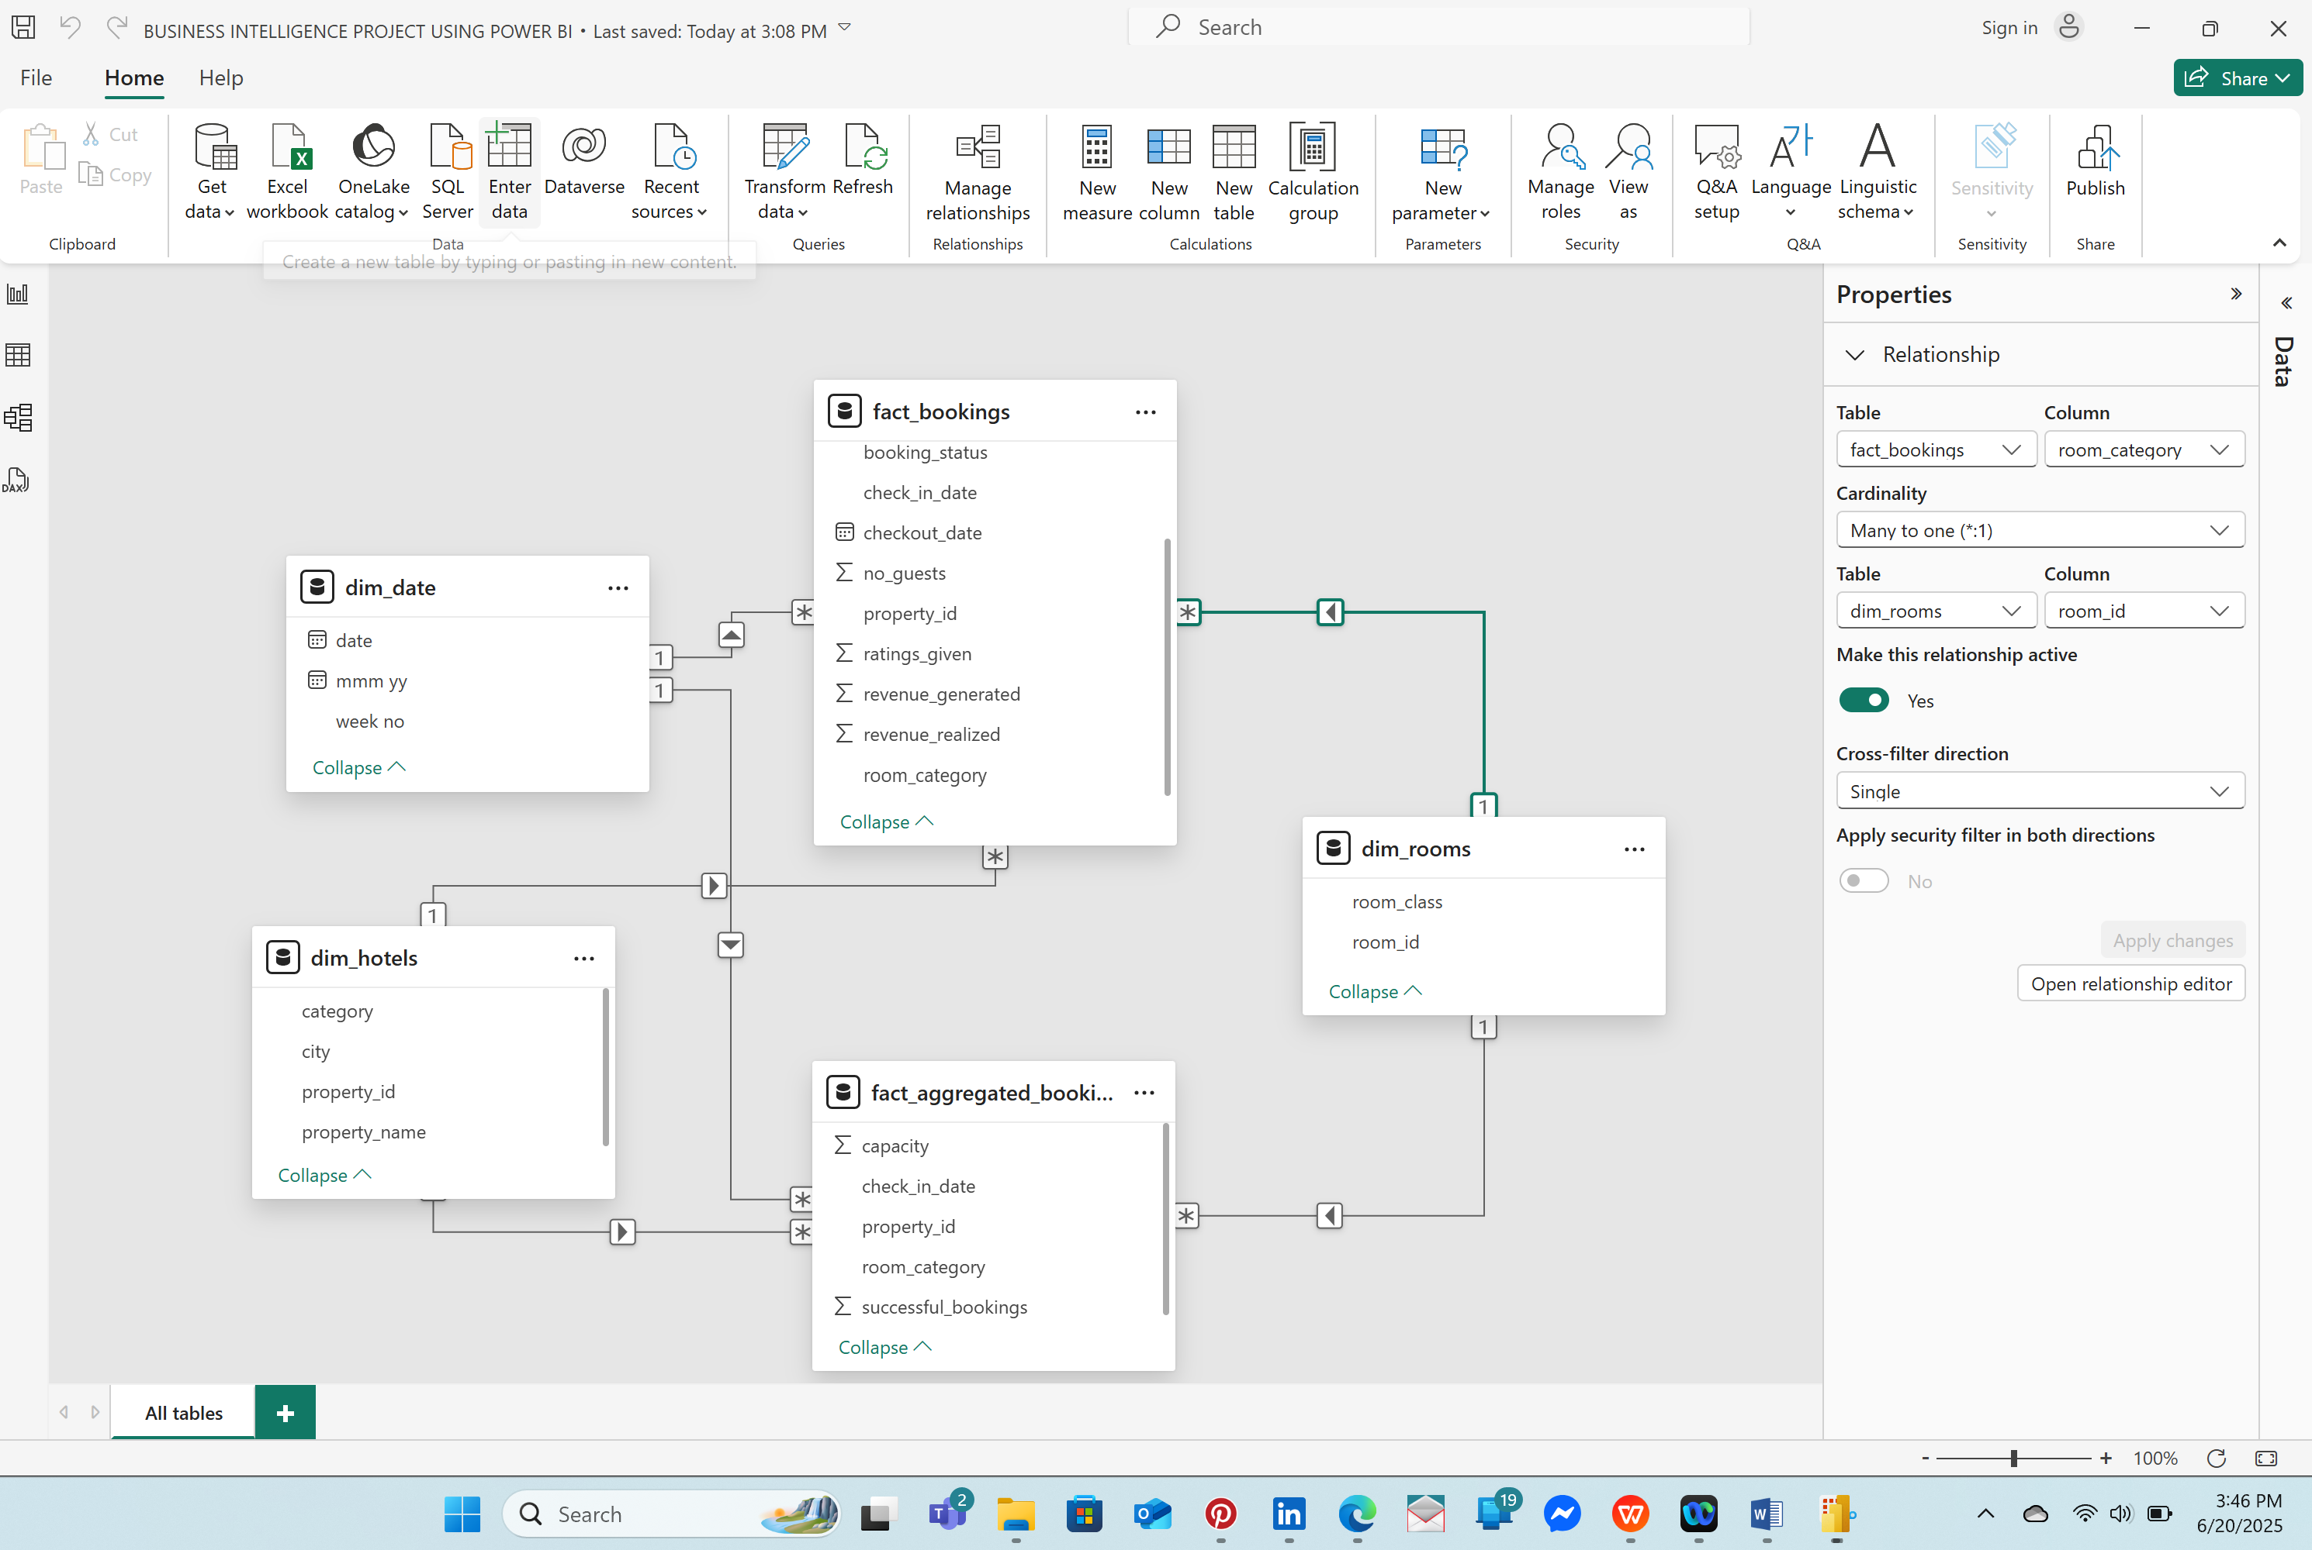

### 2.2.3📊 Data Analysis Expressions (DAX)

**Data Analysis Expressions (DAX)** is a powerful formula language used in Power BI, Excel, and other Microsoft data tools to create custom calculations and business logic within data models.

DAX enables users to build **measures**, **calculated columns**, and **calculated tables** that go beyond standard aggregations, allowing for advanced analytics such as year-over-year comparisons, cumulative totals, dynamic filtering, and key performance indicators (KPIs).

In a business context, DAX empowers analysts and decision-makers to:

* Tailor calculations to specific organizational metrics
* Generate insightful dashboards with dynamic and context-aware data
* Drive performance monitoring through customized KPIs and trend analysis

By combining DAX with a well-structured data model, organizations can unlock deeper insights, support data-driven decisions, and align reporting with strategic business goals.

### 2.2.3.1 CALCULATED COLUMNS

Using the **TABLE VIEW** option, I decided to remove the **W** in the **week no** Column on the **dim_date** table so that the column can contain only a numerical by right-clicking on the column>New Column> **DAX FORMULA USED**- **1 wn = WEEKNUM(dim_date[date]).T**his resulted to a New Column

*NOTE:* ***wn*** *stands for* ***WEEK NUMBER*** *in this case*

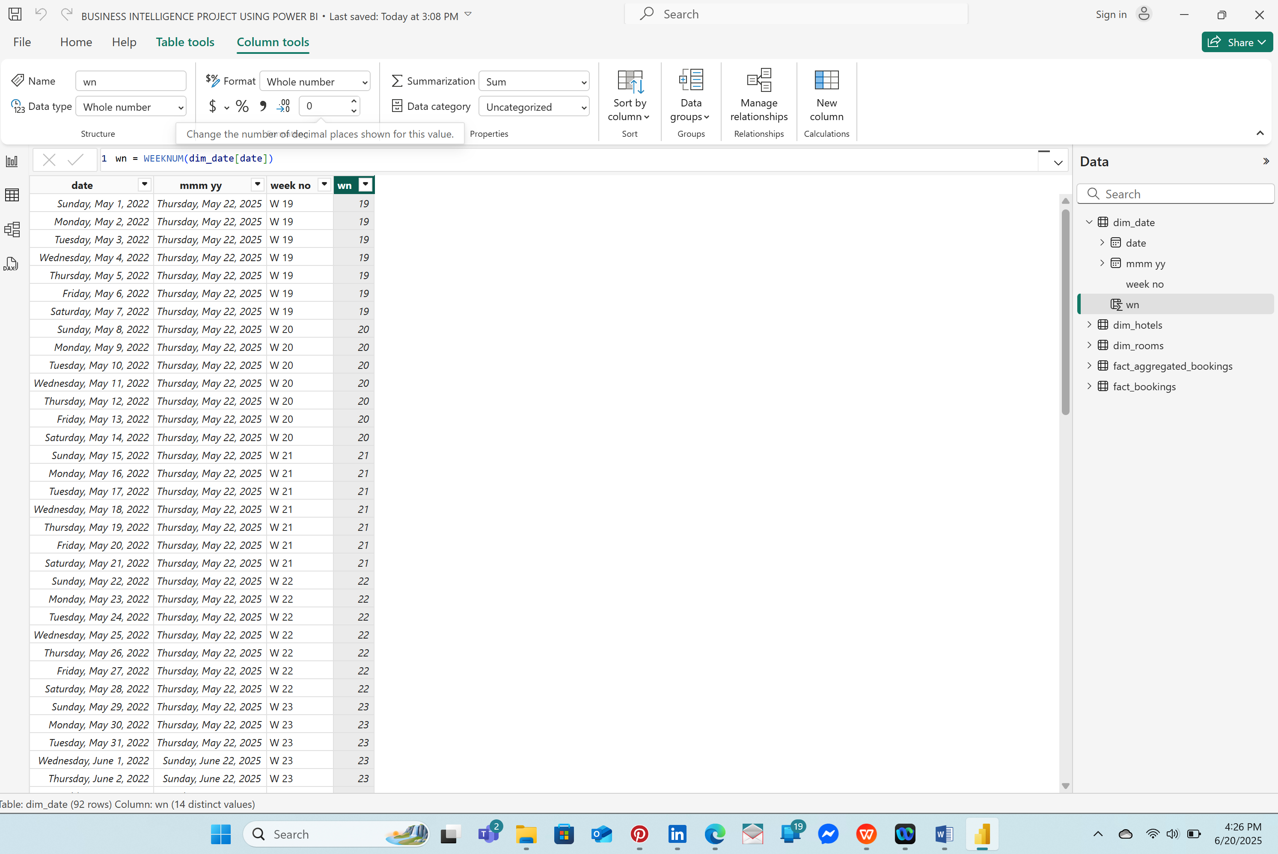

Previously,I had deleted the **day_type** column that indicated the **WEEKEND AND WEEKDAY** info.So adding another column that represents this concept, using the DAX FORMULA>day_type = WEEKDAY(dim_date[date])

The days are number from 1 to 7 with Sunday being 1 and Saturday being 7 in ascending order.So if the weekday number is > 5 then it is a weekend and in this case it is Saturday and Friday,Sunday is therefore a weekday as per the hotel booking business In India mentioned in the problem statement.

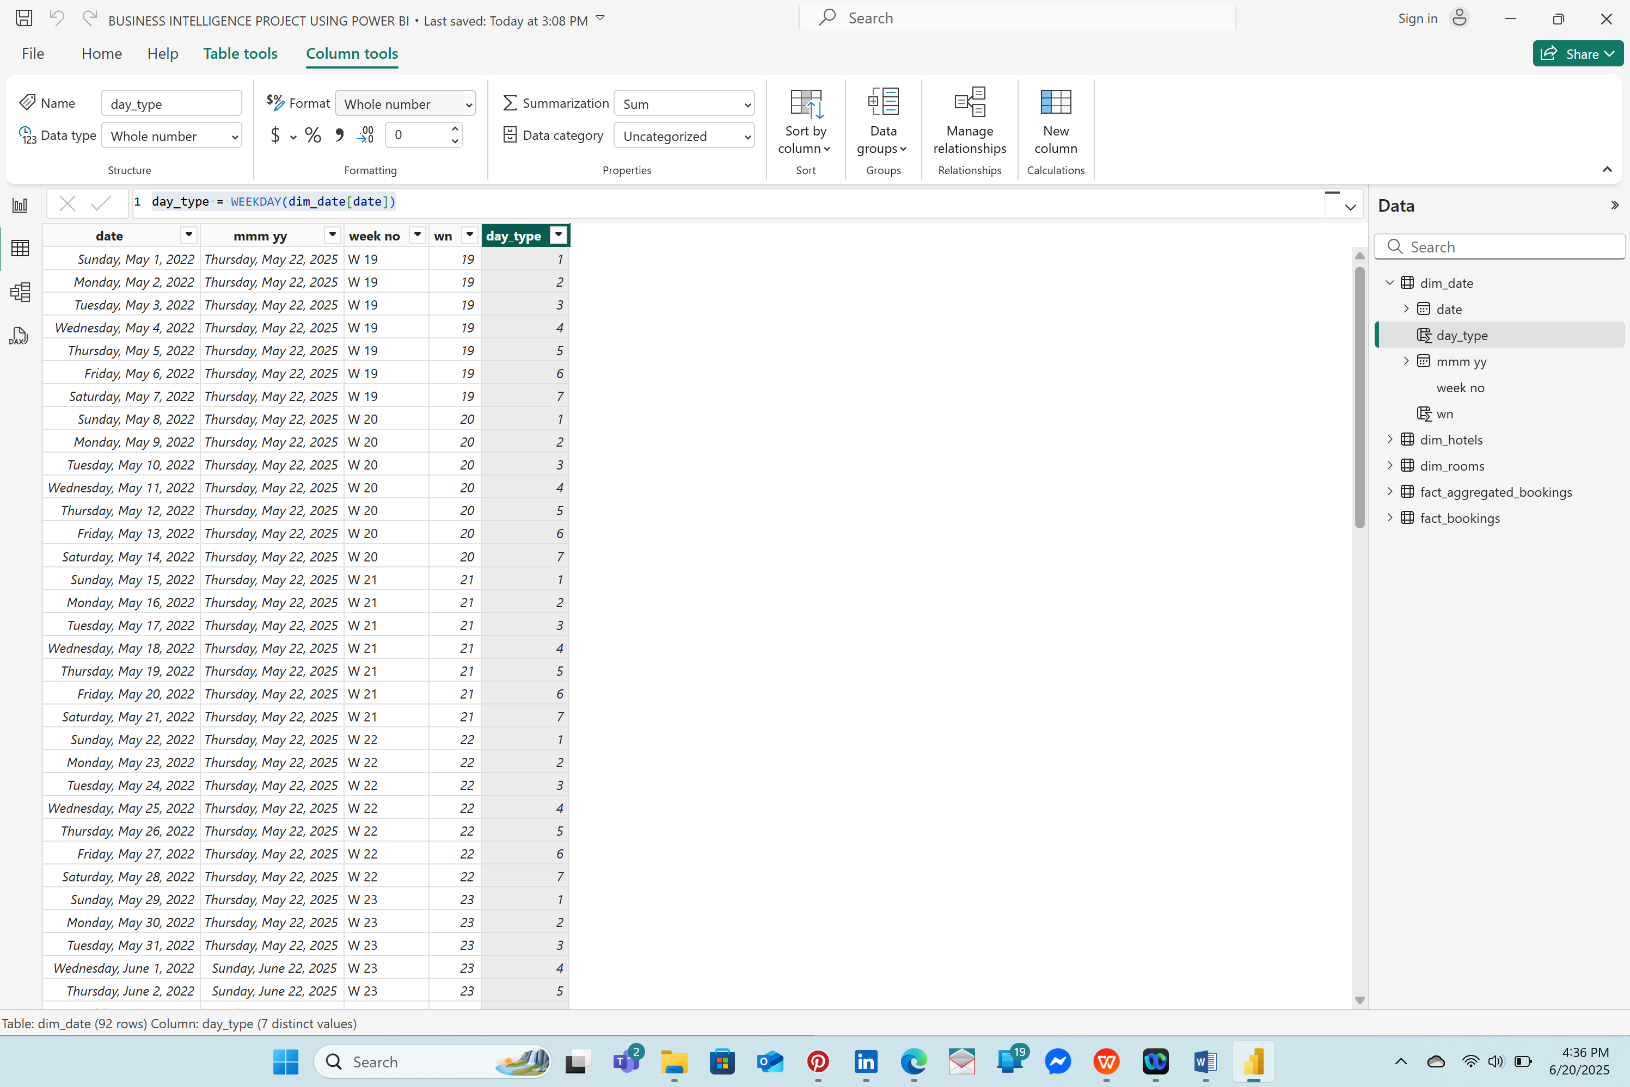

***USING A VARIABLE***

Place Cursor at the end of the formula and **press ALT and ENTER at the same time to** write more formulas.

**DAX FORMULAS USED:**

day_tpe =

var wkd = WEEKDAY(dim_date[date])

return if(wkd> 5,"Weekend","Weekday")

This results to CALCULATED COLUMNS using DAX.

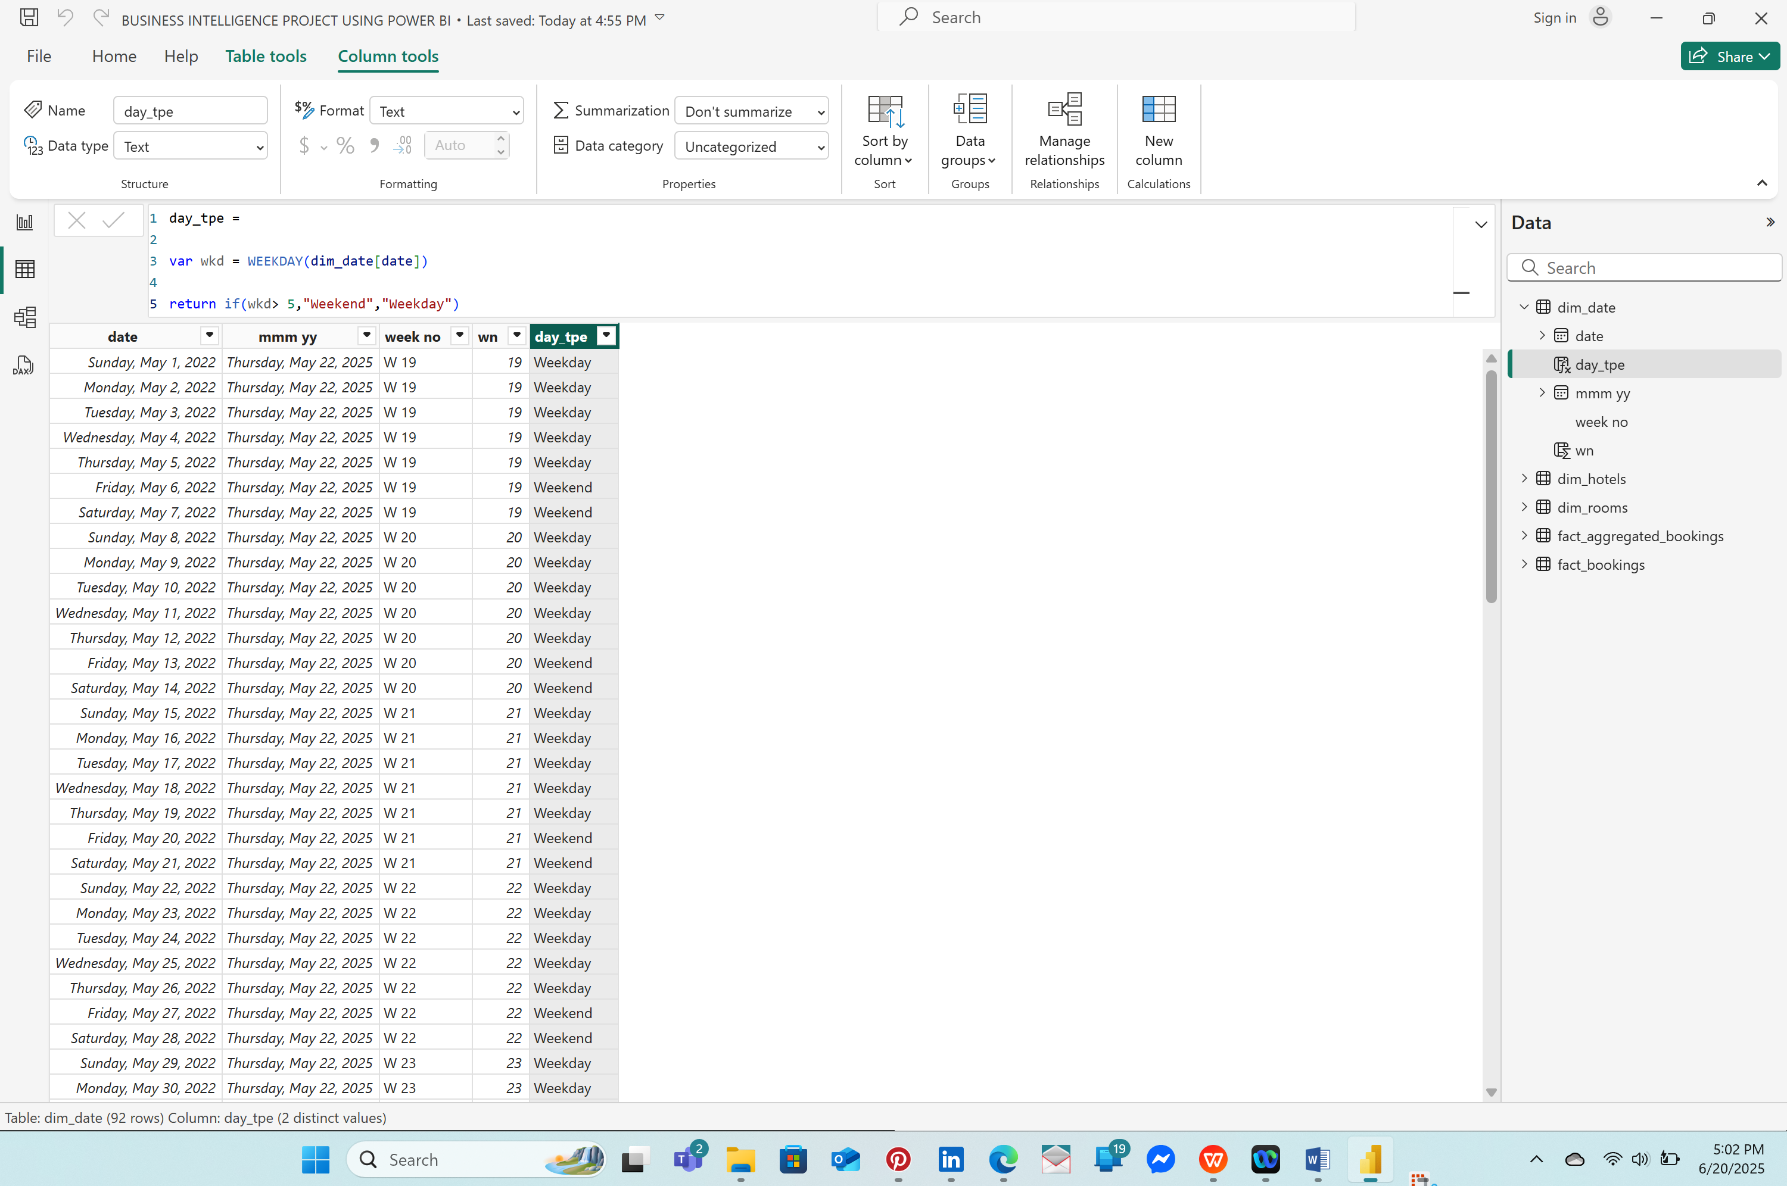

### : CREATING KEY MEASURES

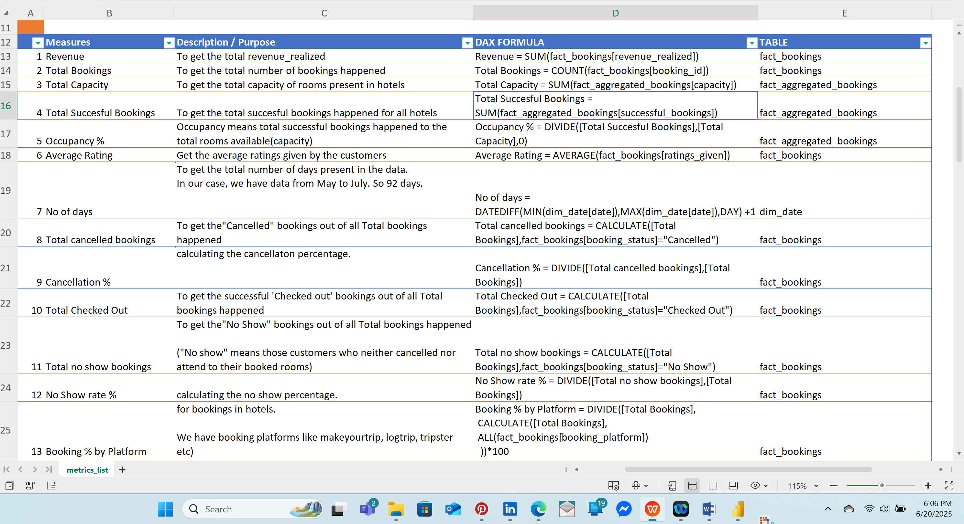

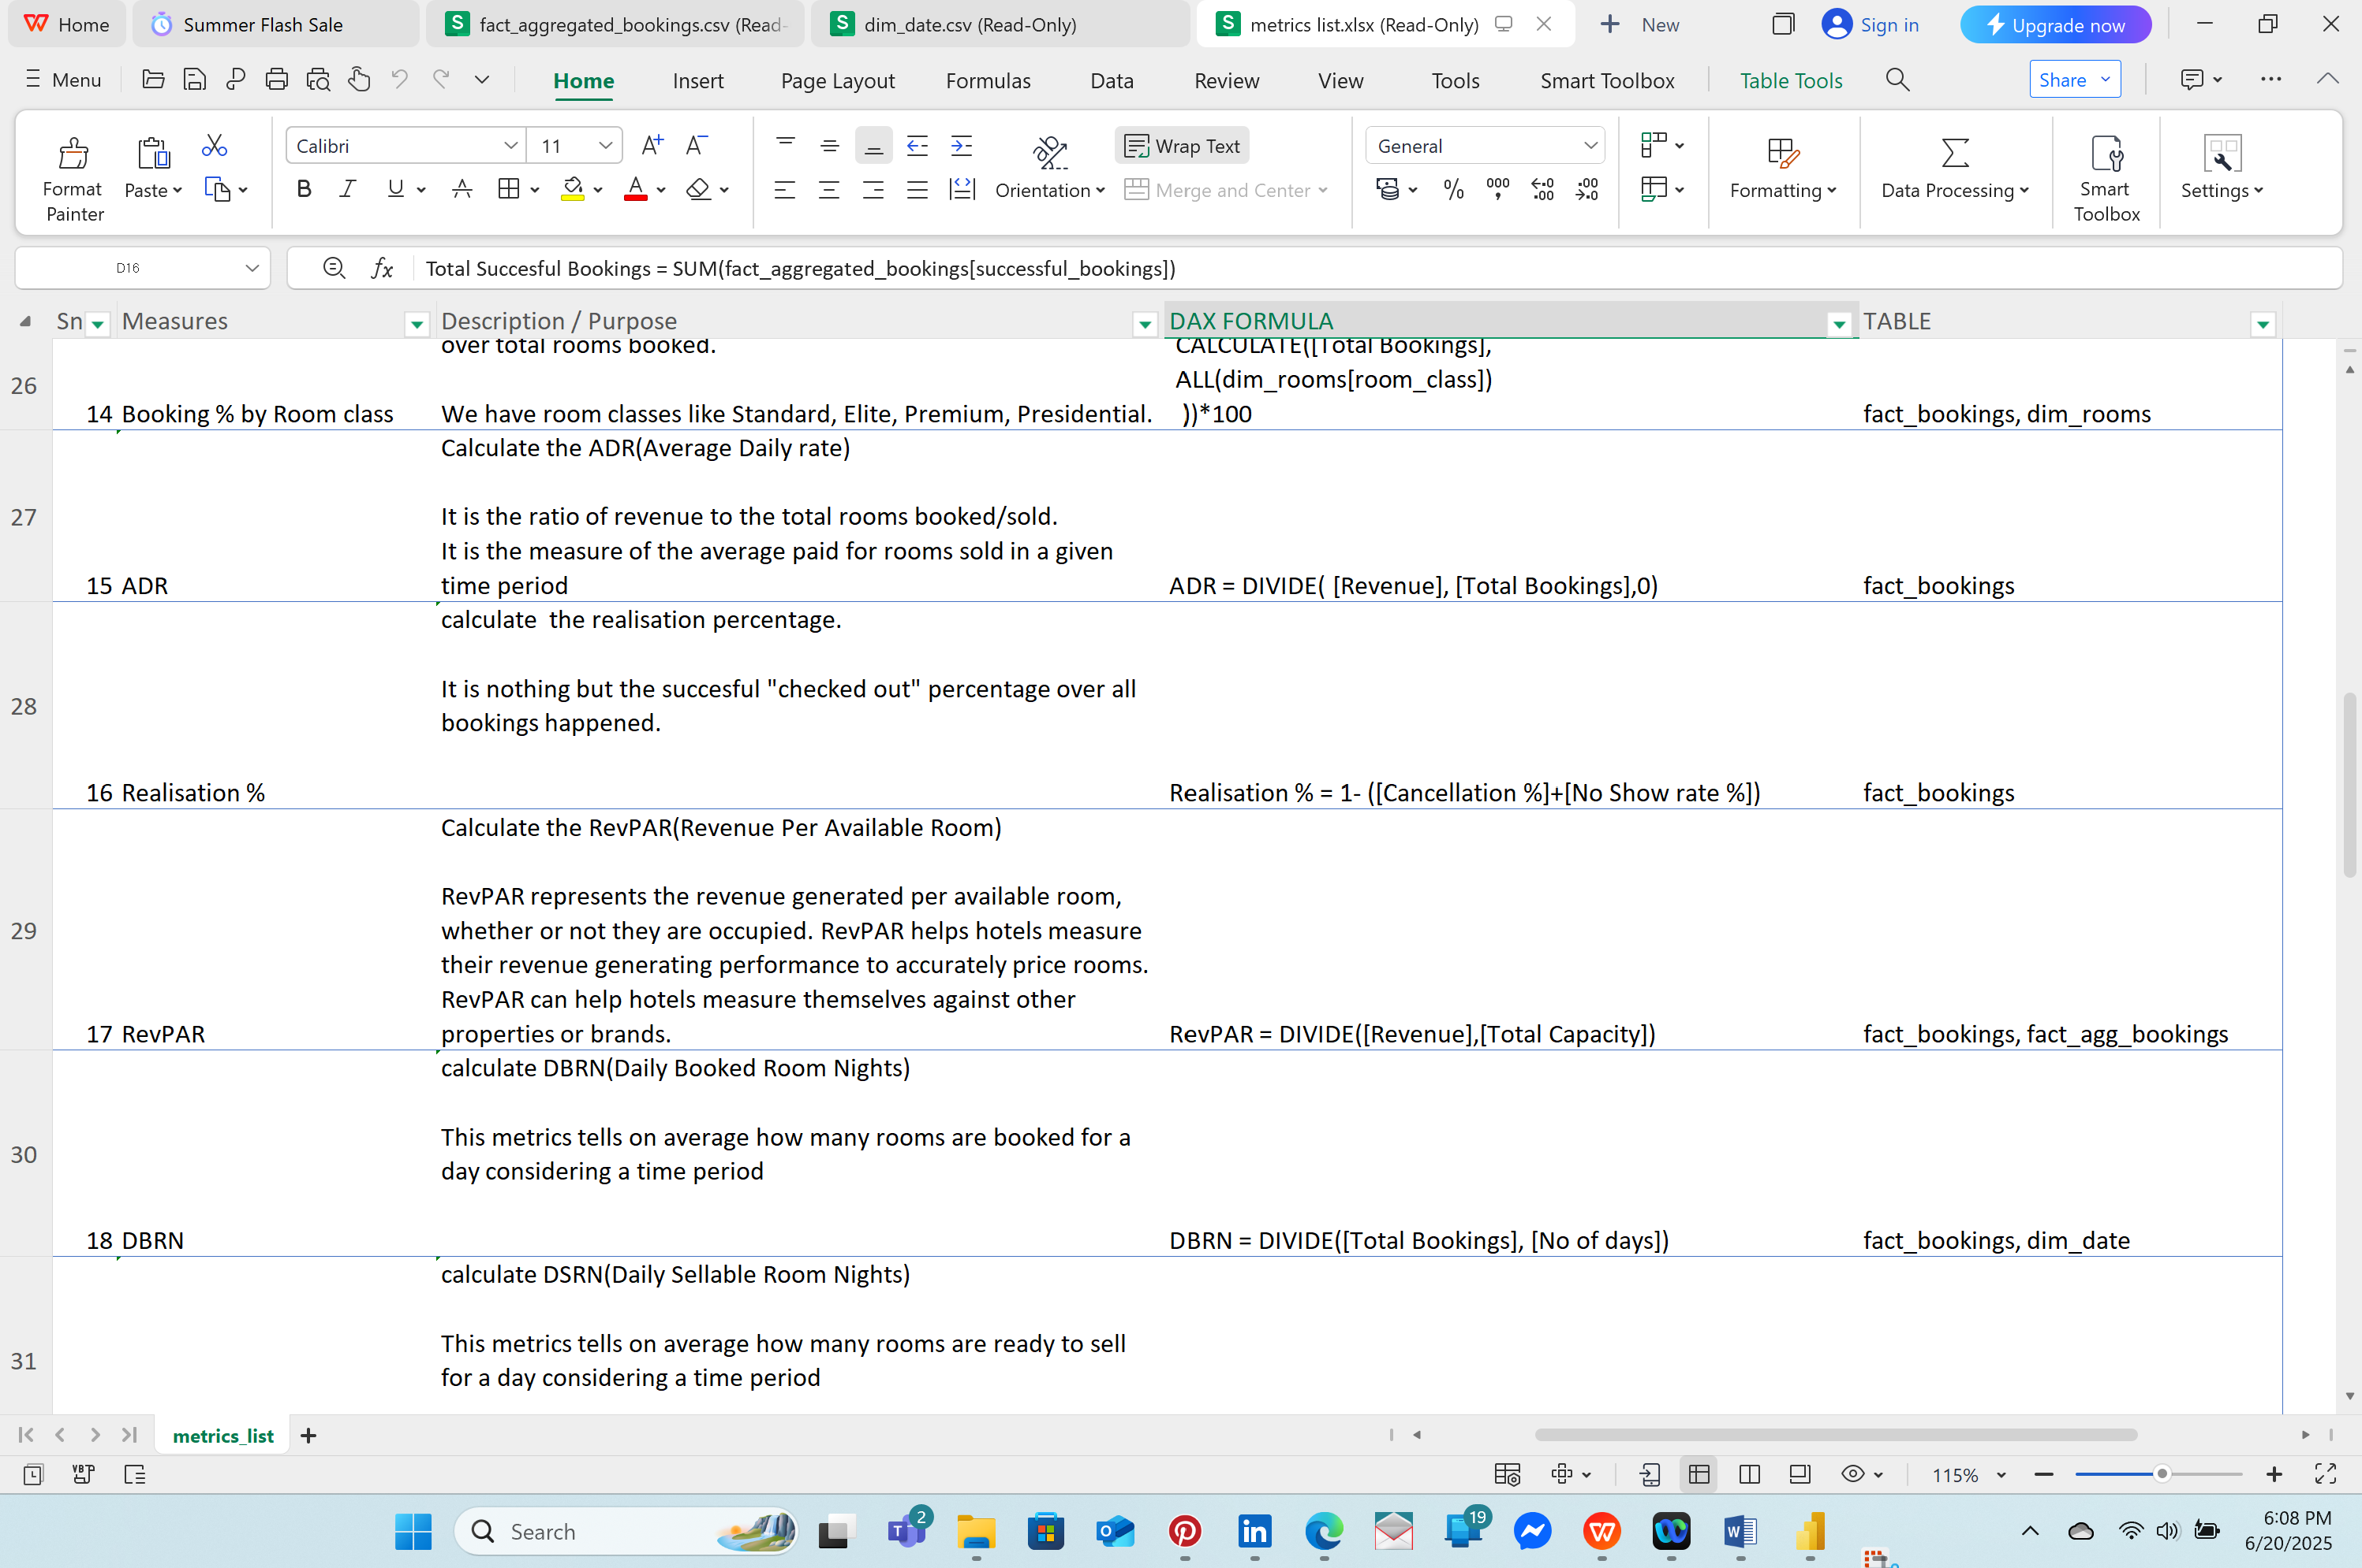

***1.REVENUE***

Click on **REPORT VIEW>THE THREE DOTS AT THE FIELDS MENU>NEW MEASURE>REVENUE>DRAG & DROP REVENUE**

Alternatively, To group into Separate Categories, CLICK **ENTER DATA** on the HOME tab ,on the **Table prompt,delete and rename as KEY MEASURES and press ENTER**

Click **KEY_MEASURES>COLUMN 1>NEW MEASURE** and use formula Revenue = SUM(fact_bookings[revenue_realized]) and then DRAG & DROP Revenue to the center of the Workspace.

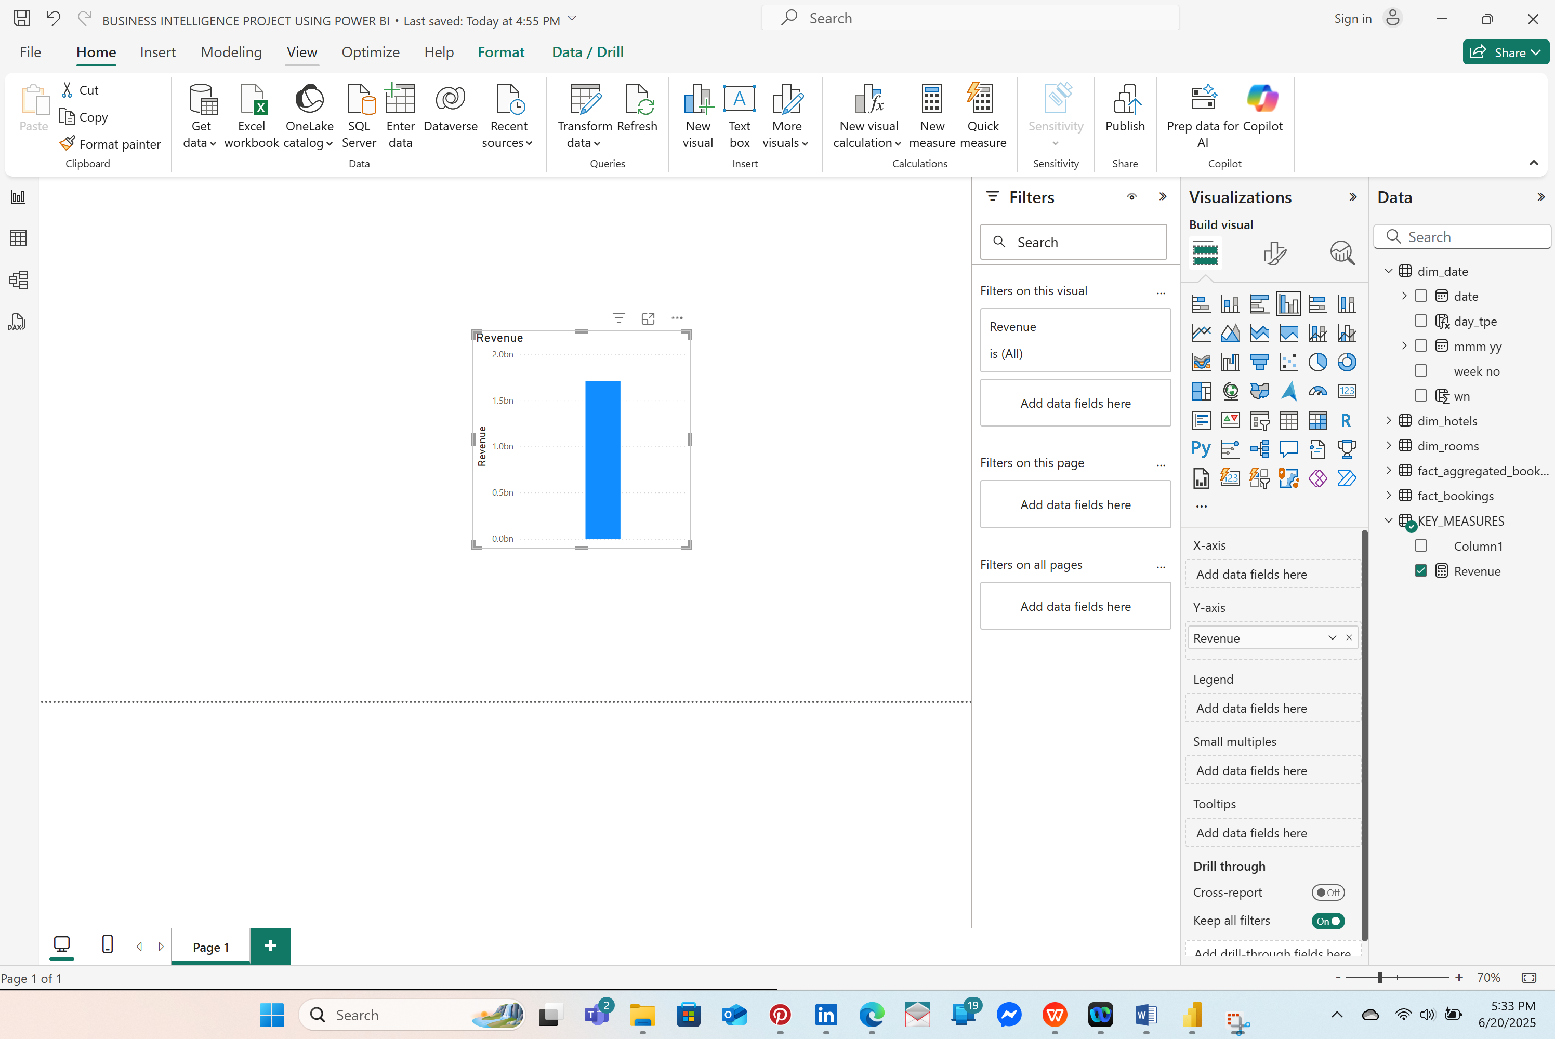

You can click on the CARD icon Under Visualizations to view it as a figure.

GO to Visualizations>General>Apply Settings to and select Revenue> Decimal places and it will give a total revenue of 1.7087712.. 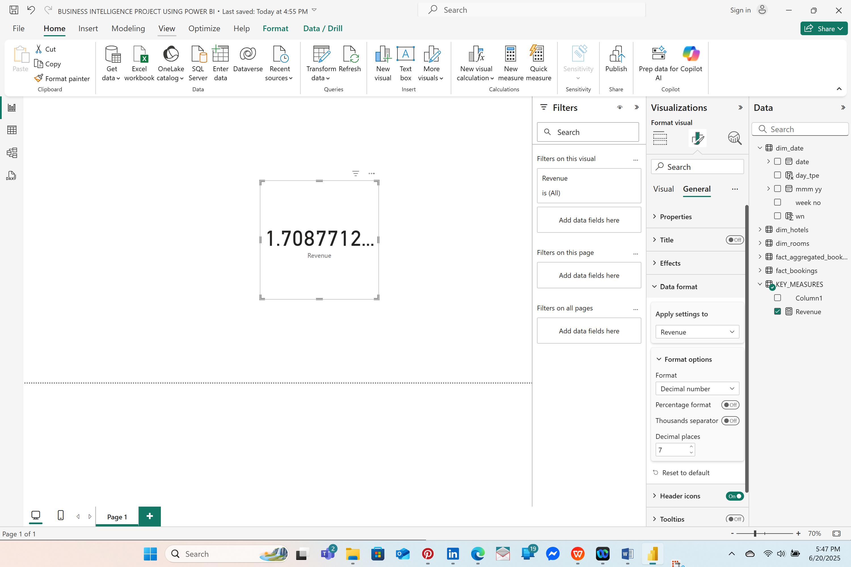

To check Revenue from a particular property say 16558,click dim_hotels>property_id>drag and drop property_id to the center of the workspace and it will show a figure of 36.06117M and 16559 will be 118.44841M and on and on 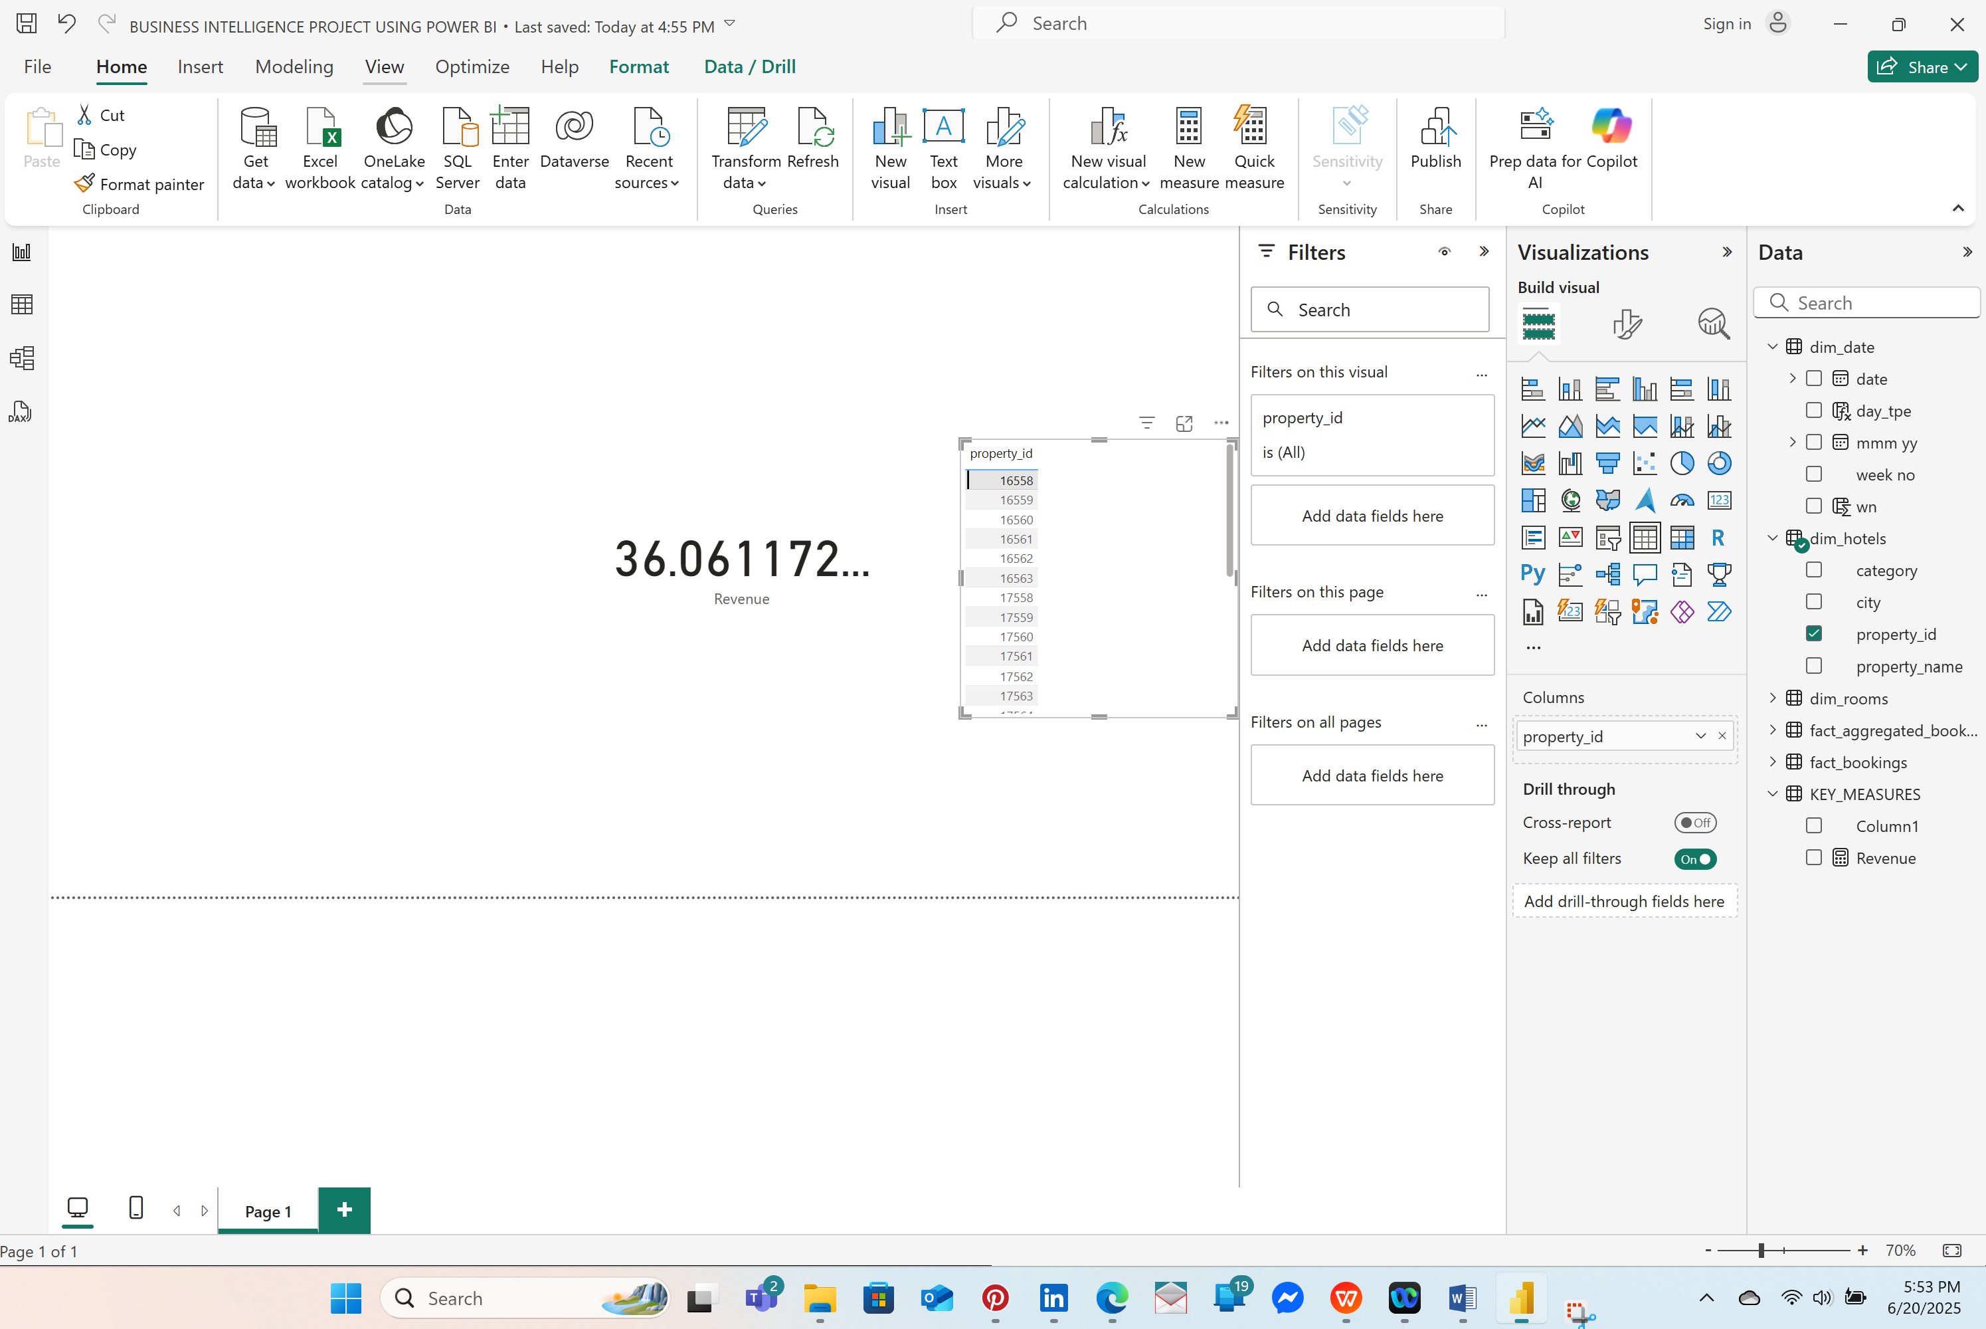

**OTHER KEY MEASURES CREATED:**

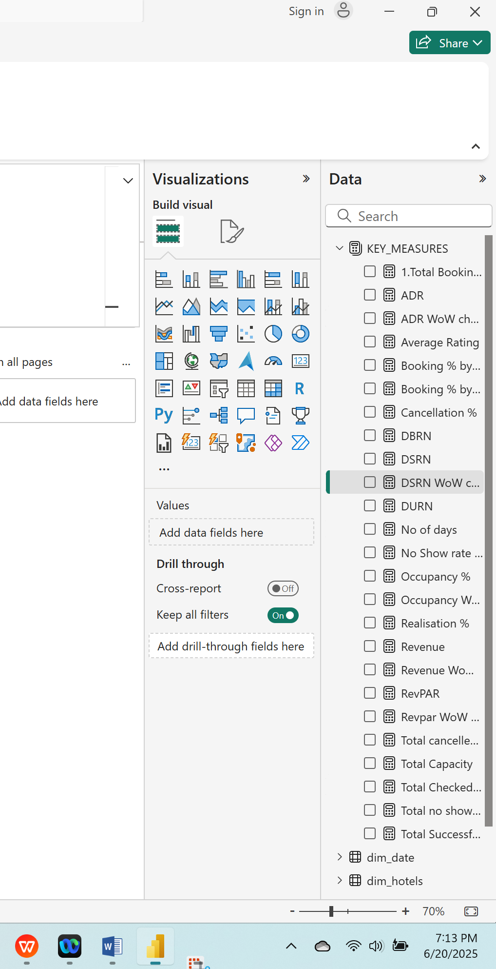

# **2.3: DASHBOARD CREATION**

Dashboarding with Power BI involves creating interactive visual representations of data to help users monitor key metrics, analyze trends, and make informed decisions. Power BI, a business analytics tool by Microsoft, allows users to connect to various data sources, clean and transform data, and build rich dashboards using visual elements like charts, graphs, maps, and KPIs.

Dashboards in Power BI are highly customizable and dynamic, enabling real-time data updates and user interactivity through filters and slicers. They are commonly used in business reporting, performance tracking, and data storytelling across industries. Whether for executives needing a high-level overview or analysts diving into detailed data, Power BI dashboards make complex data easy to understand and act upon.

### *2.3.1.CHART CREATION*

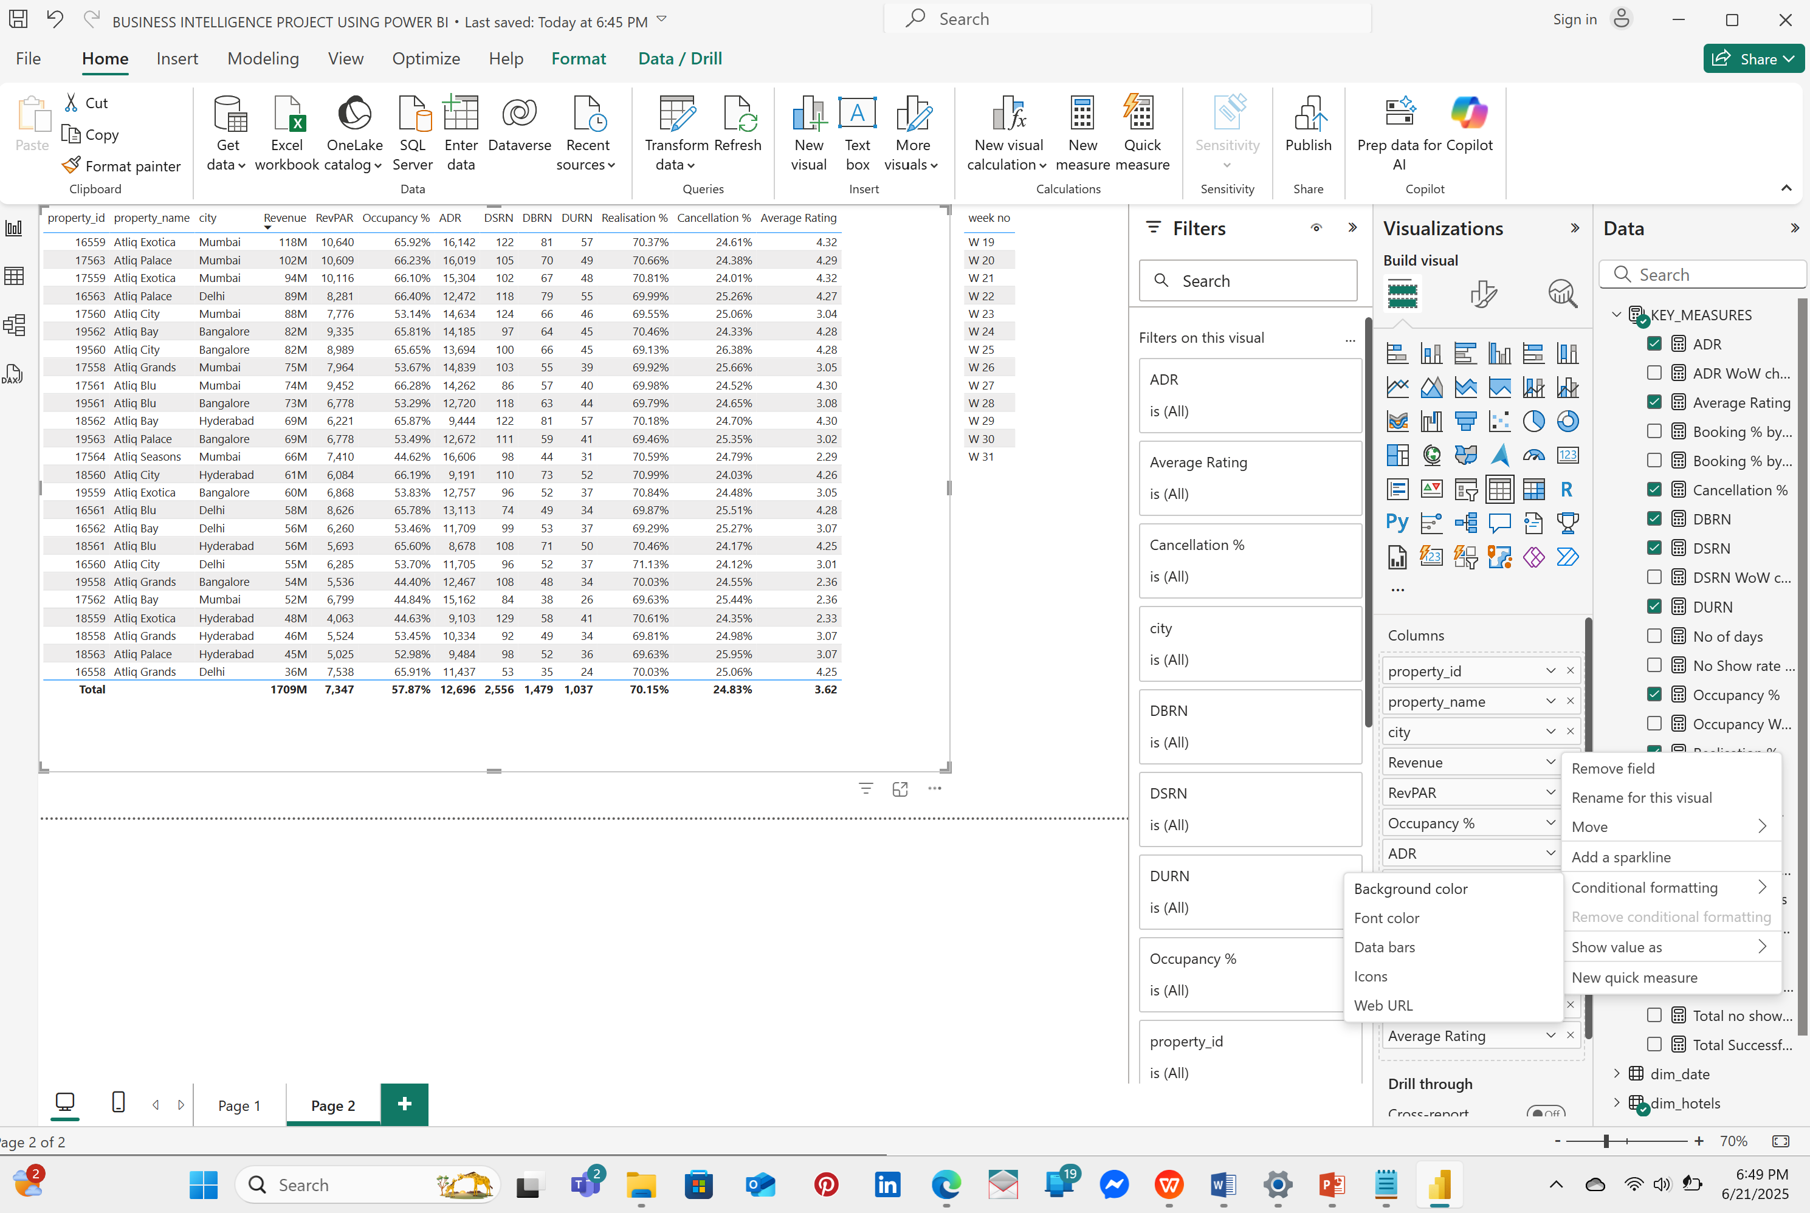

-I filtered out WEEK 32 because it only has a single dataset and it might affect my skewness.

-I change the data formatting in revenue to Millions and removed all decimal places in the chart so as to have exact values.

-In Revenue and Average Rating I applied **CONDITIONAL FORMATTING** to the Data bars and chose color purple.

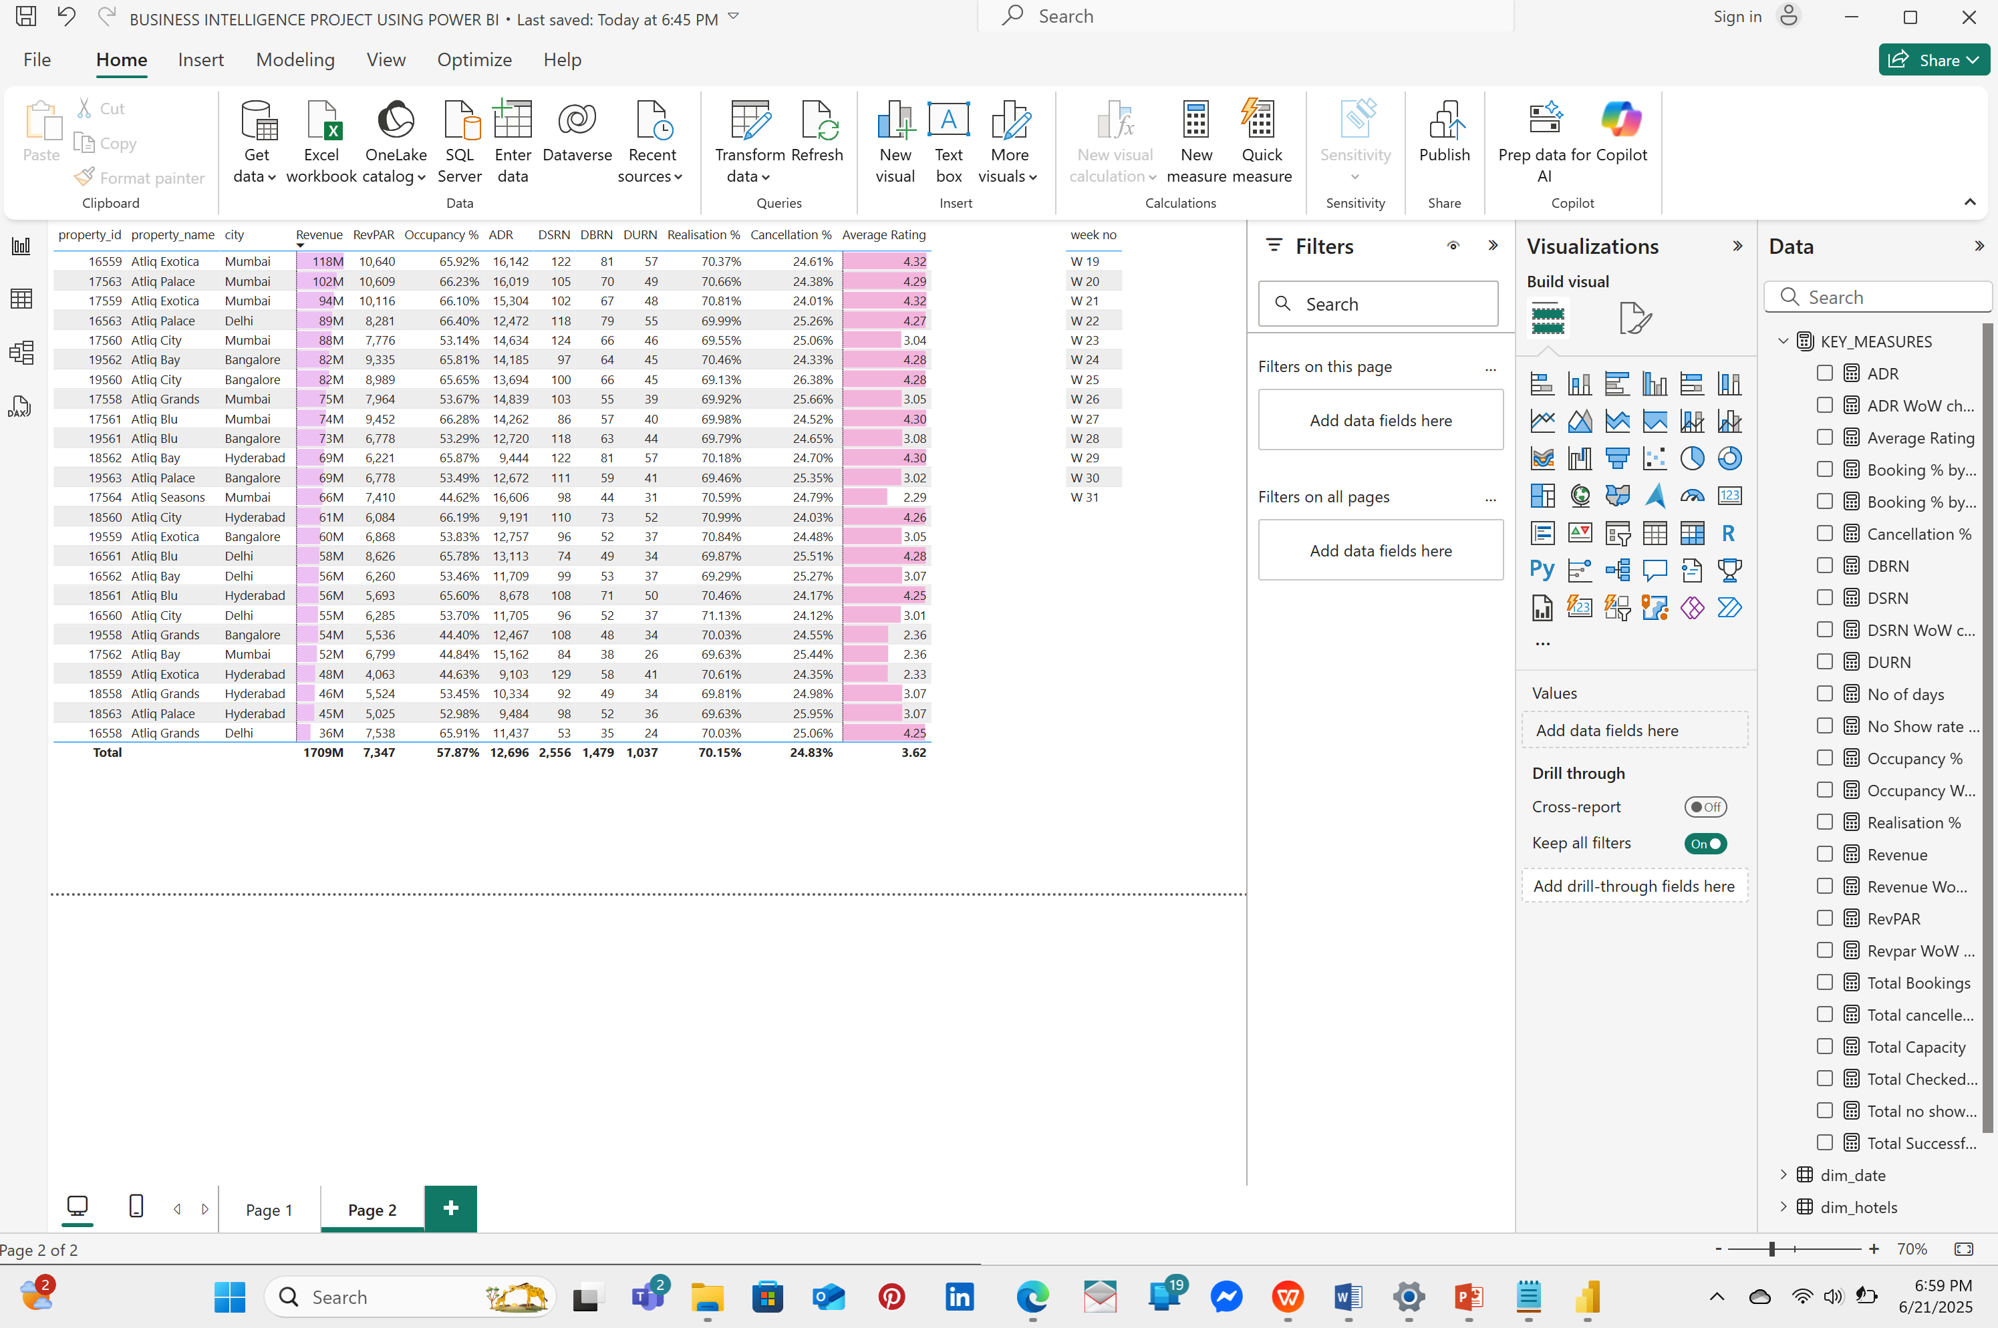

#### 2.3.2: ADDING SLICER TO ALLOW FILTERING OF CONTENTS

-CITY

-ROOM TYPE

-PROPERTY ID

-PROPERTY NAME

-MONTH

-WEEK NO.

This allows me to filter results from a particular table with ease. 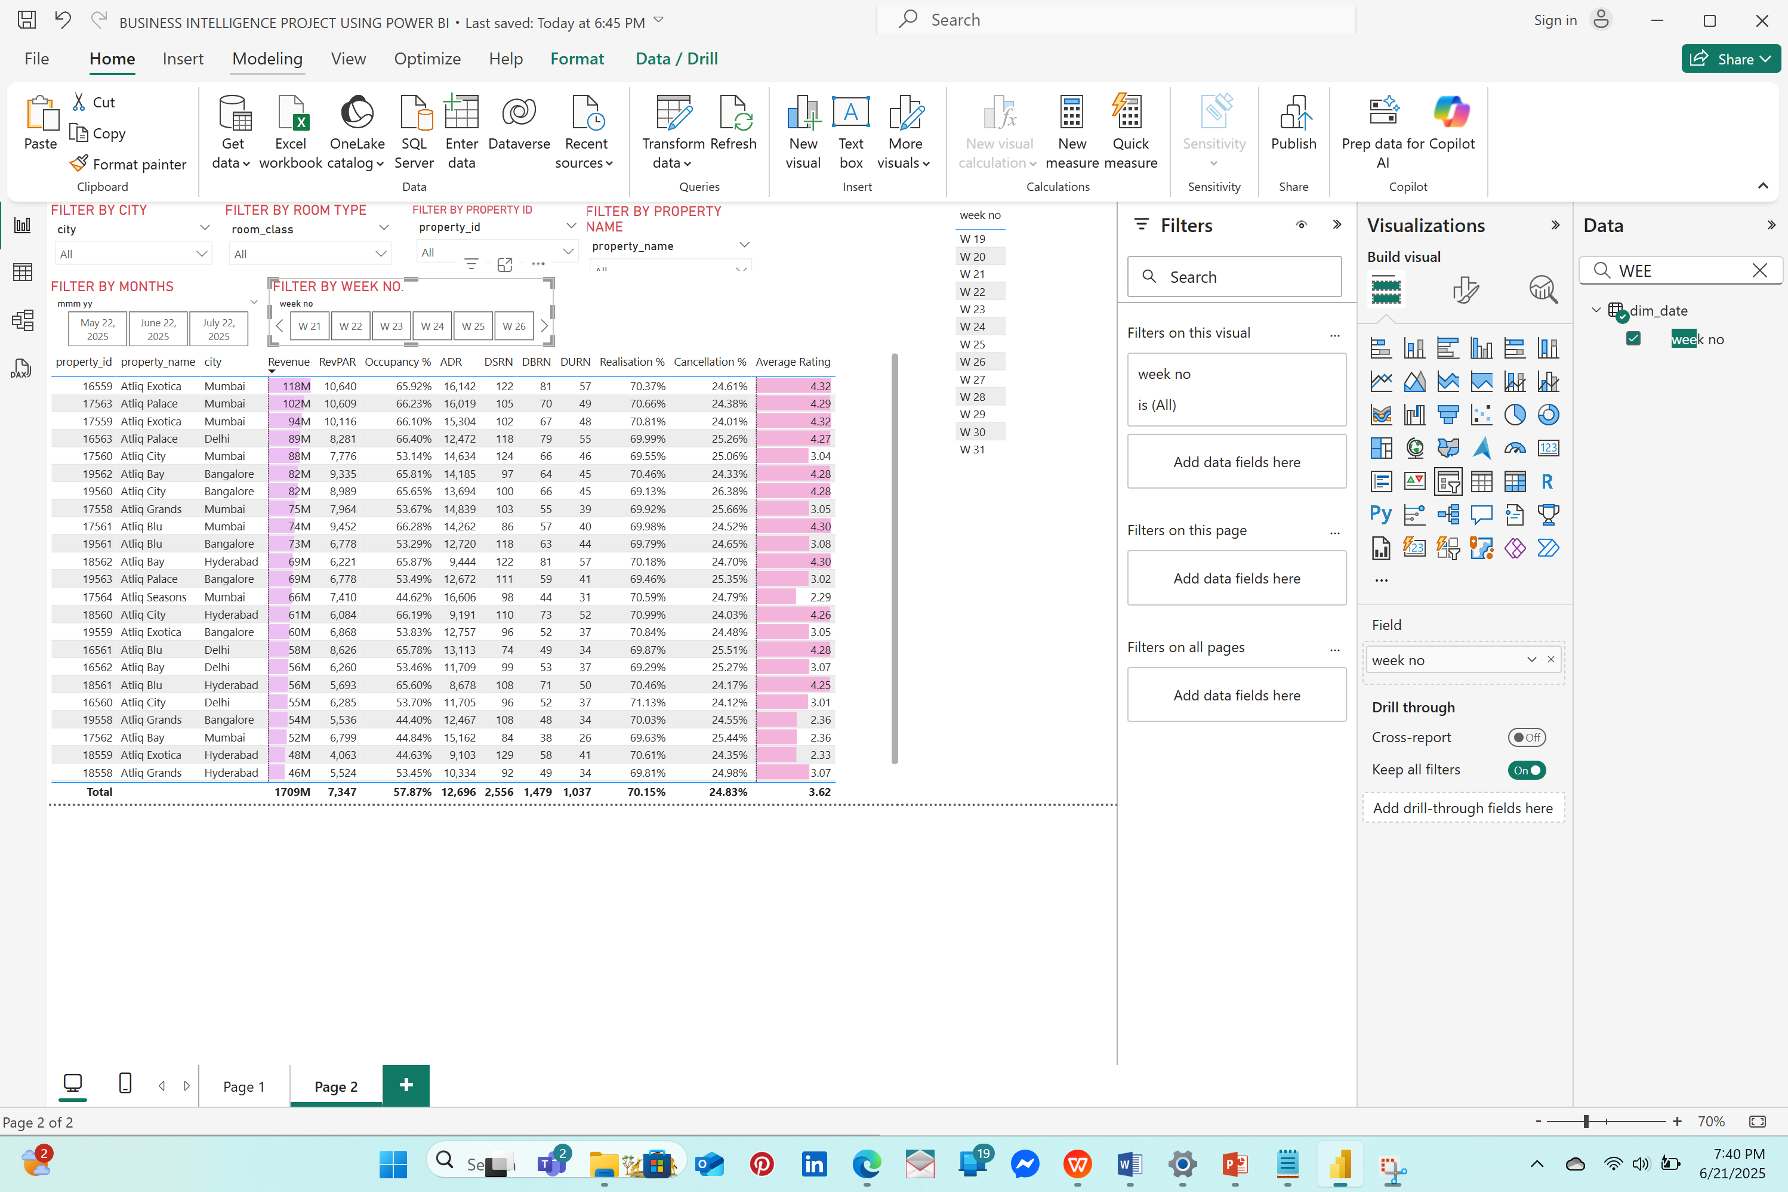

### 2.3.3: ADDING KEY PERFORMANCE INDICATORS

**>ICONS TO REVENUE WEEK ON WEEK CHANGE %**

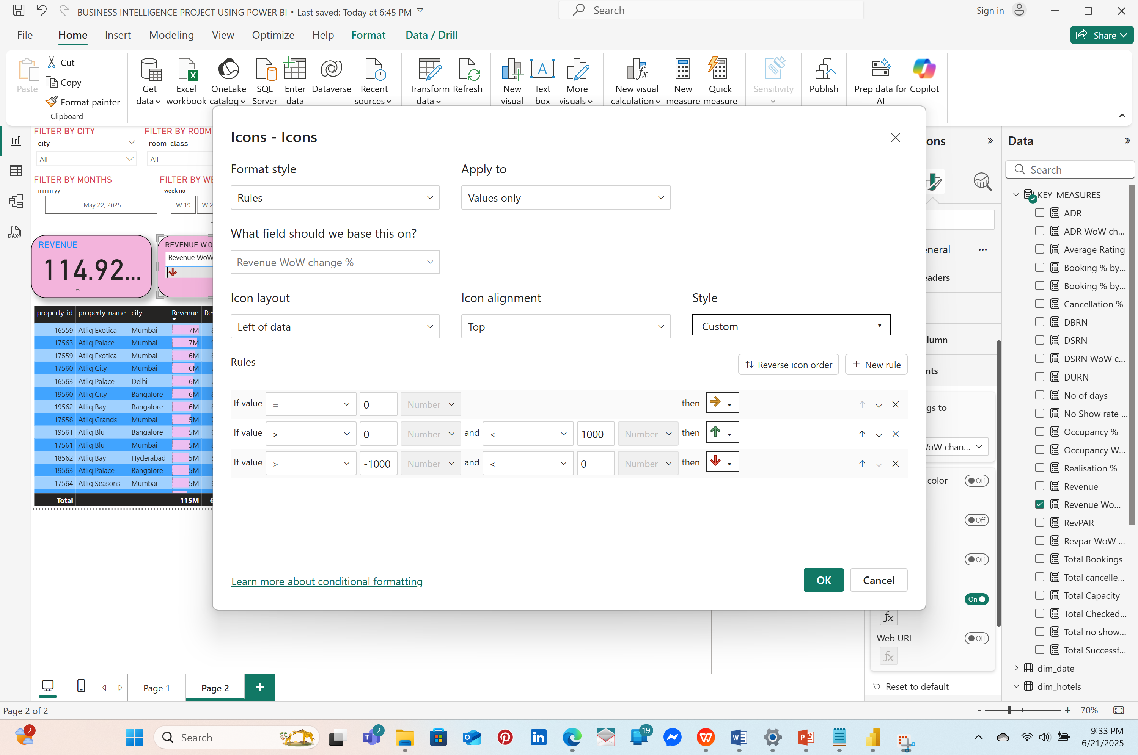

**>CREATING TRENDS ON REVENUE**

X-AXIS-WEEK NO.

Y-AXIS- [REVENUE] BY [CATEGORY]

*TIP:TURN ON DATA LABELS AND MARKERS AND TURN ON’ ALLOW TO USE AS A TOOL TIP’ ON PAGE INFORMATION.*

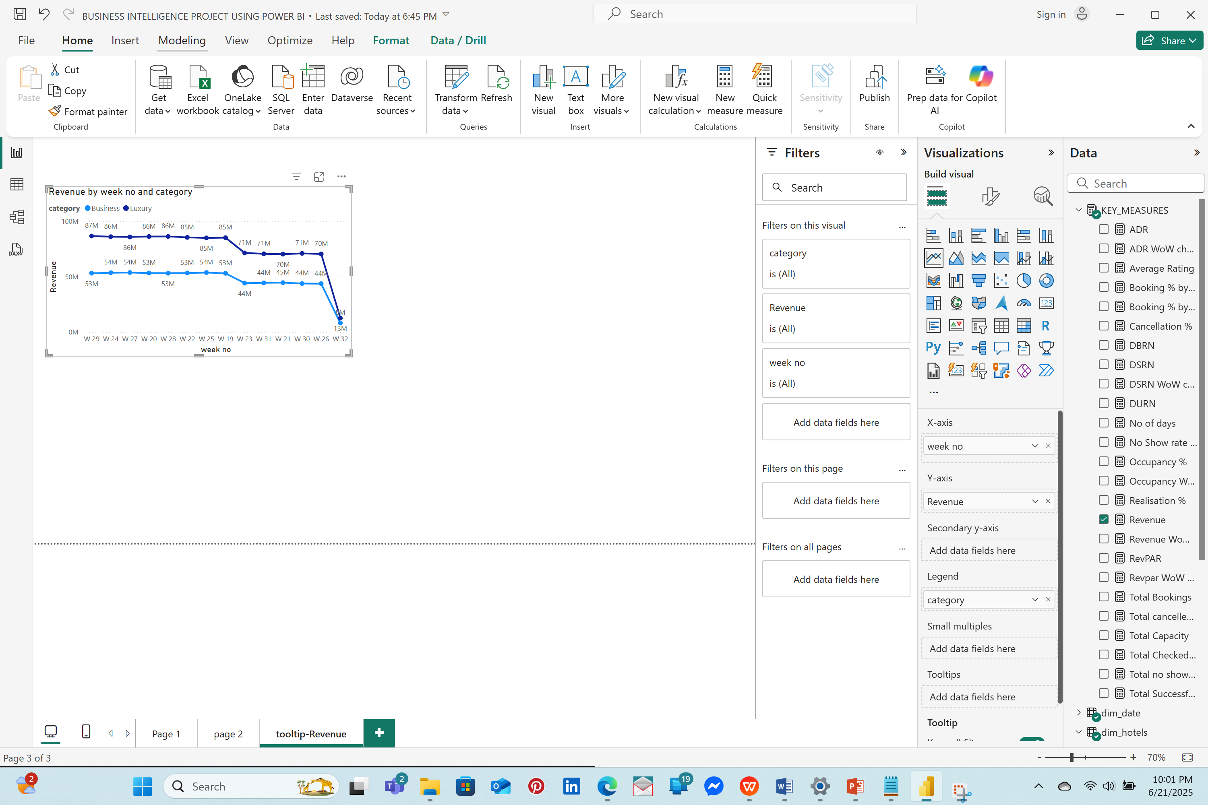

>**CREATING TOOLTIPS**

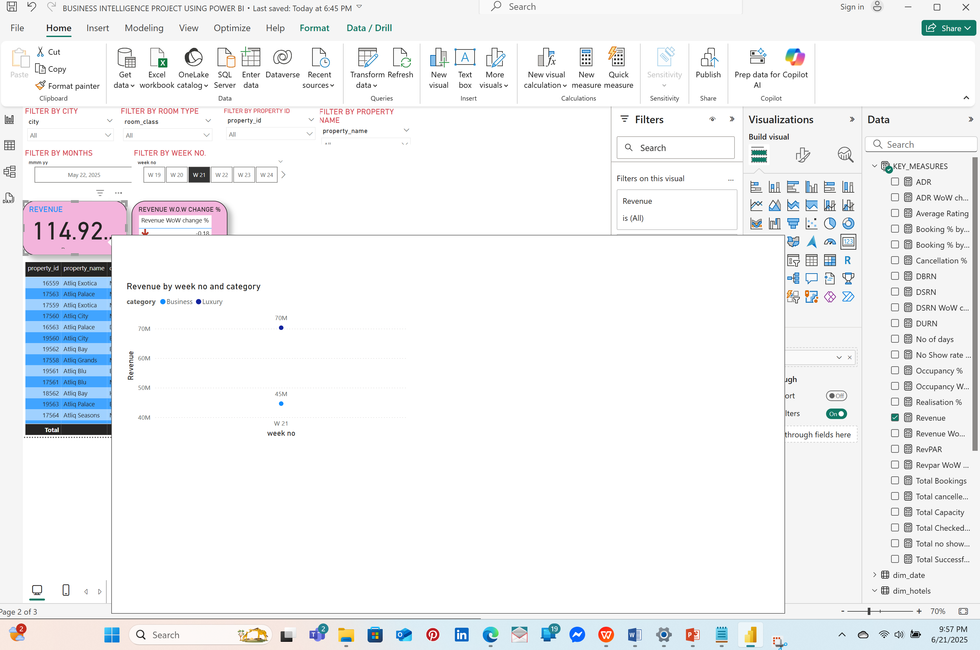

>**CREATING DOUGHNUT CHARTS**

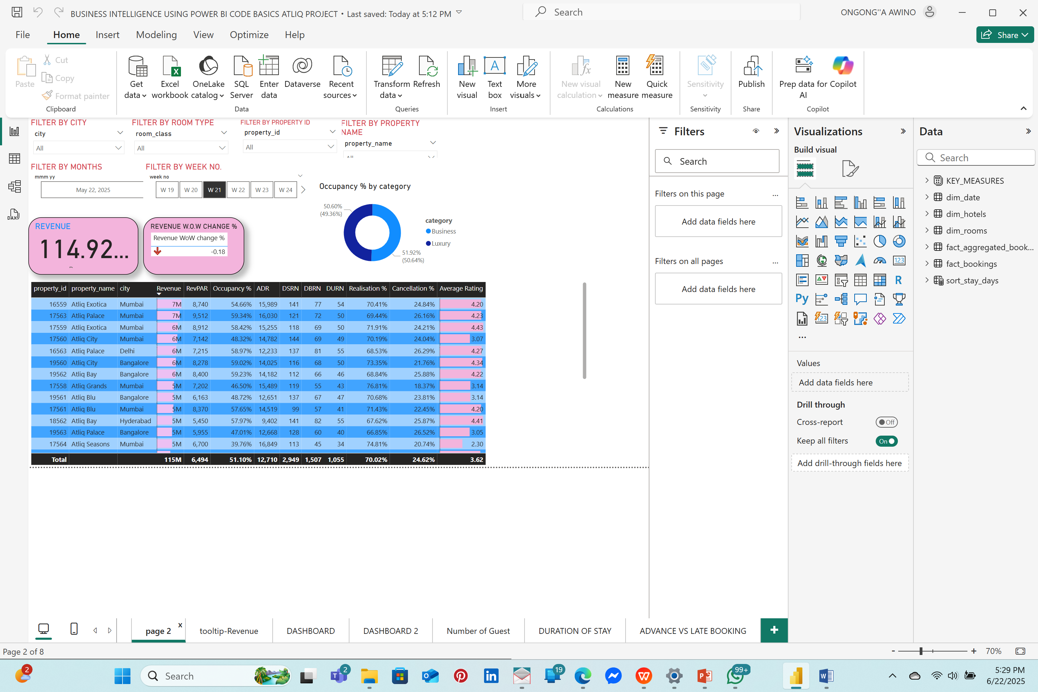

LEGEND-CATEGORYVALUE-OCCUPANCY %.

This shows how much percentage is going in business and how much is going into luxury. Z

>CREATING DASHBOARD 1 USING BAR CHARTS

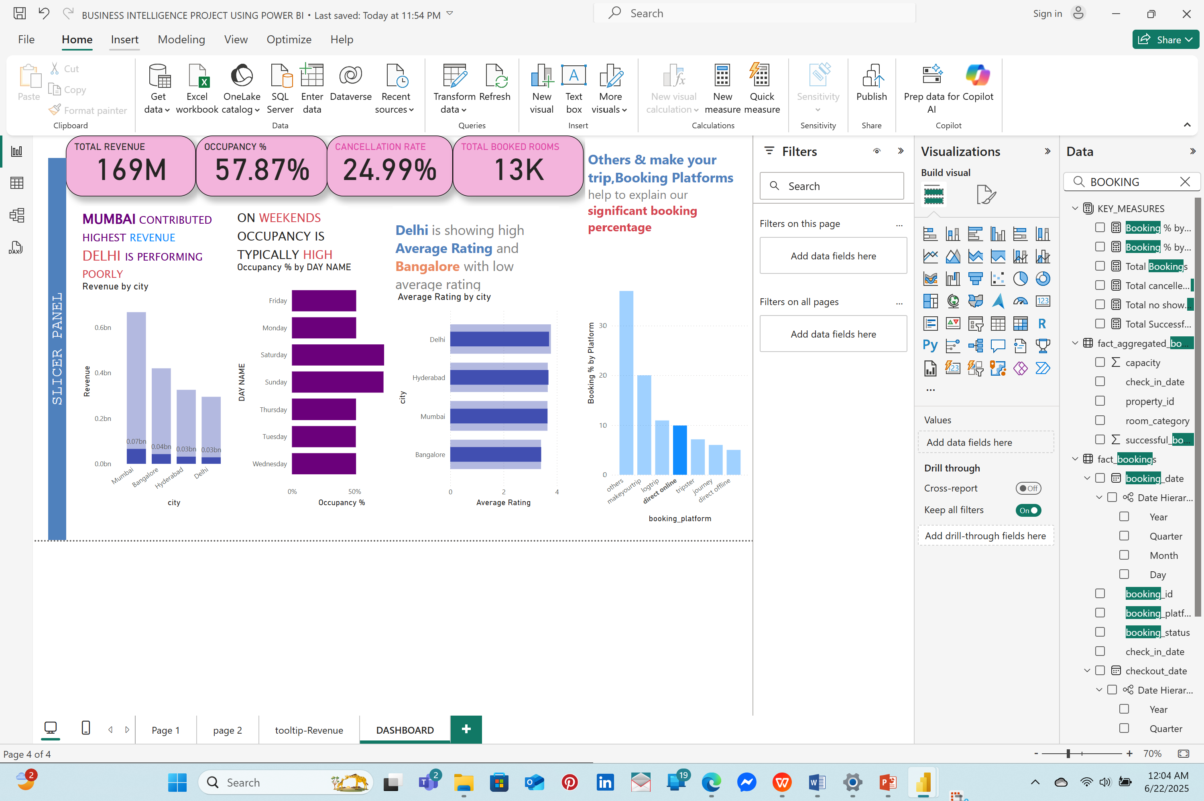

### 

### >CREATING DASHBOARD 2

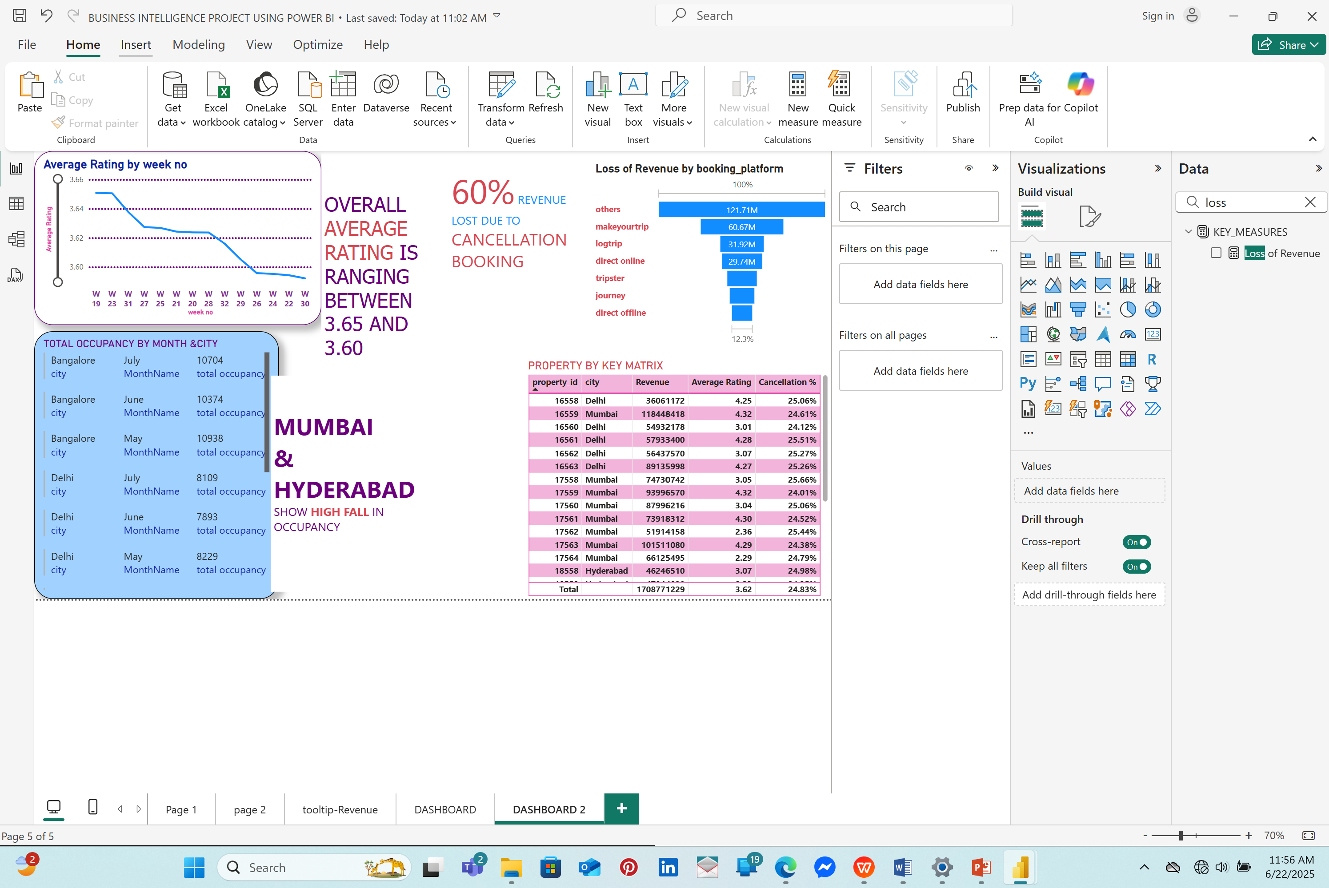

**>**CREATING DASHBOARD 3

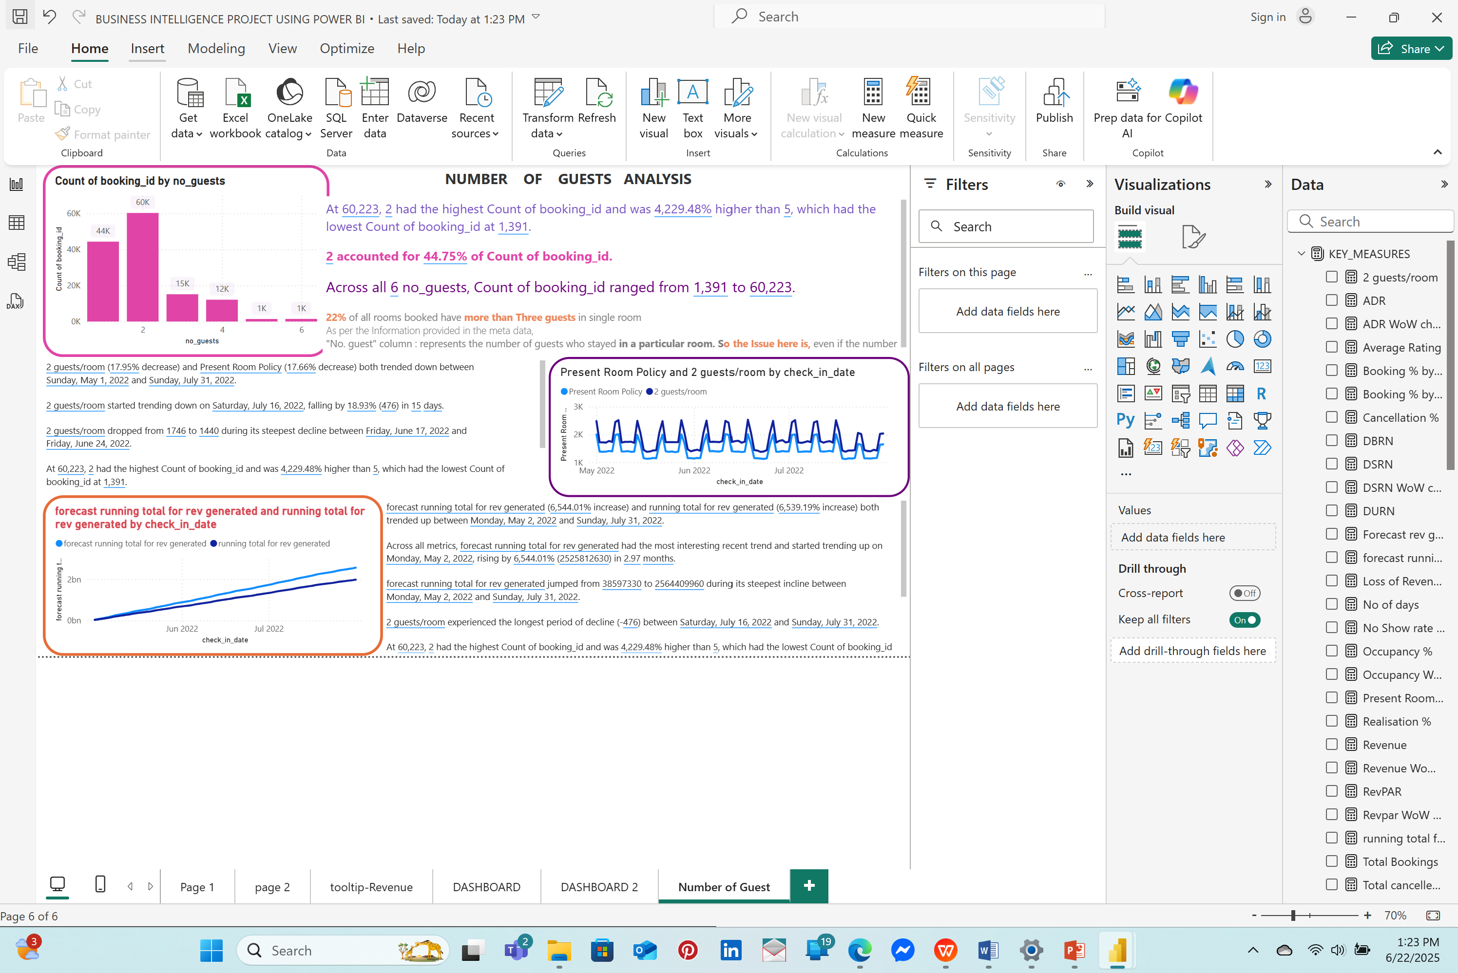

**>**CREATING DASHBOARD 4

*NEW TABLE*

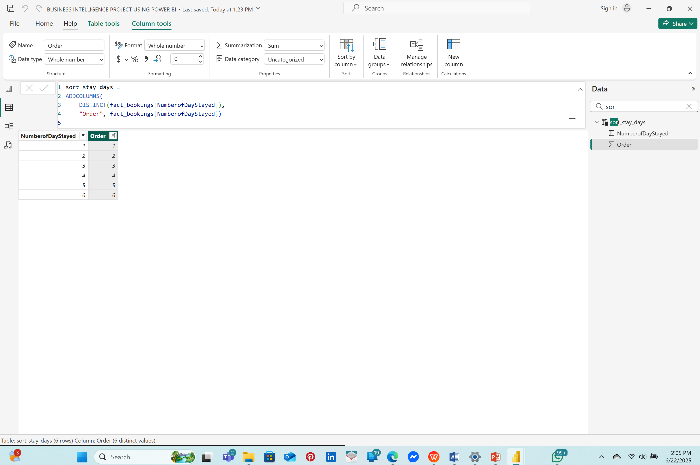

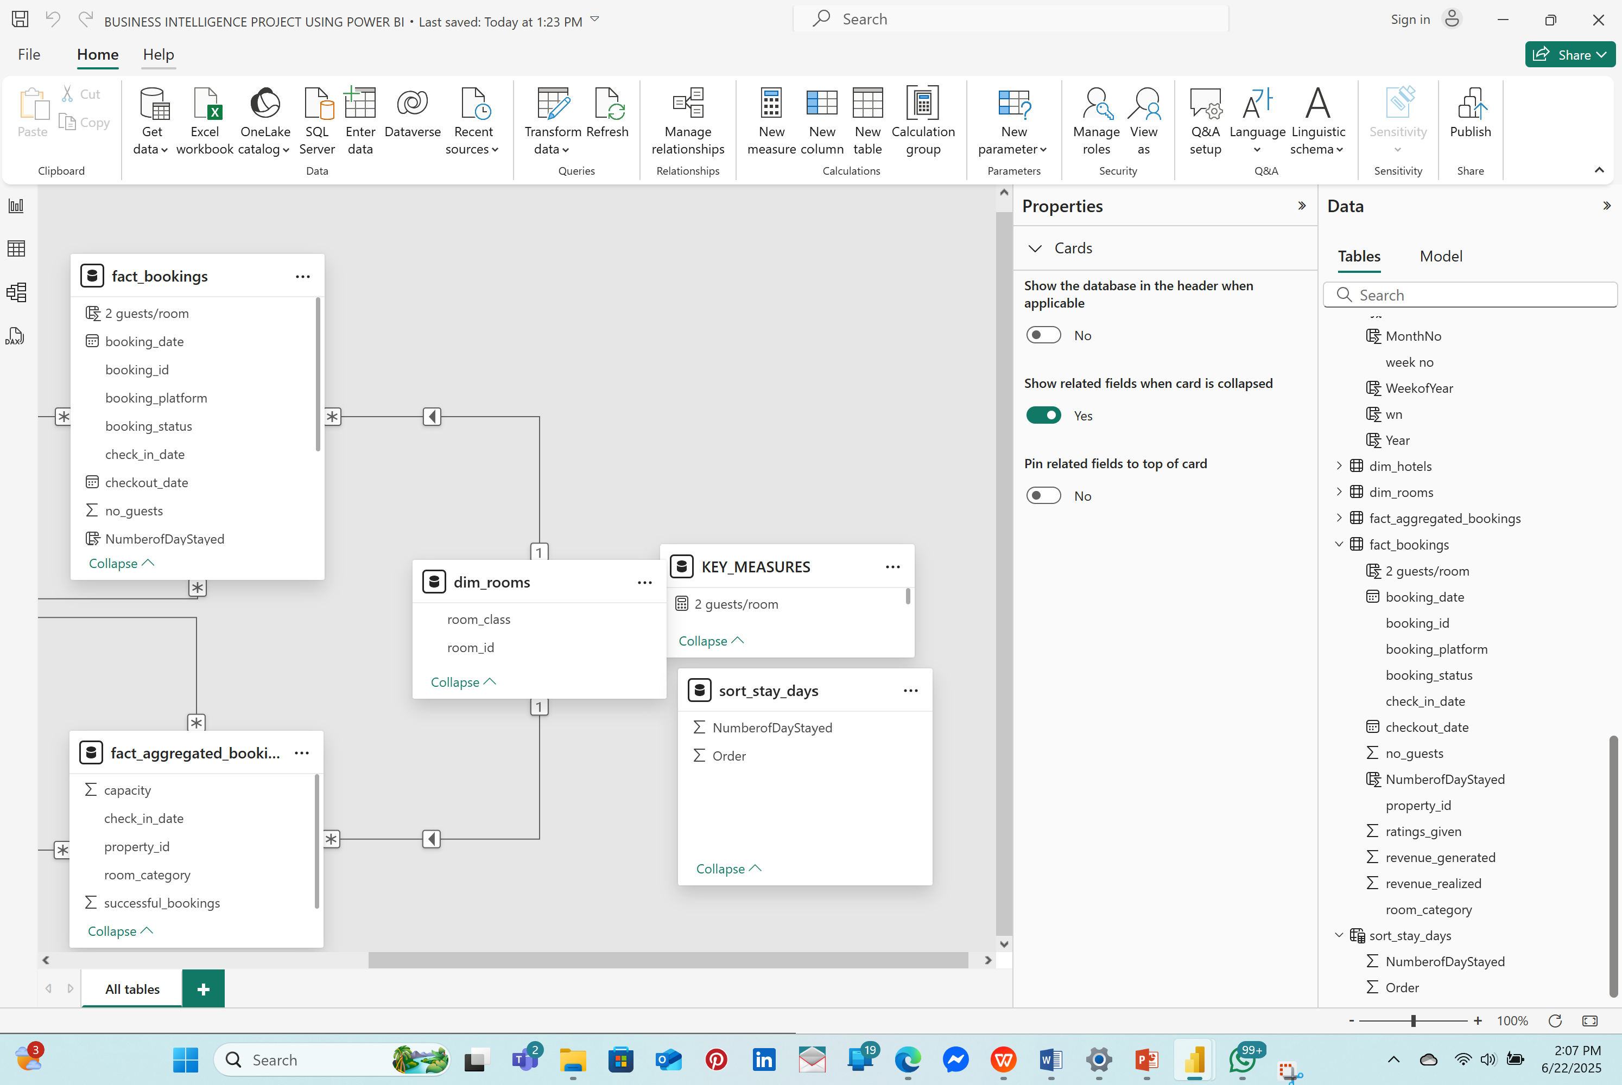

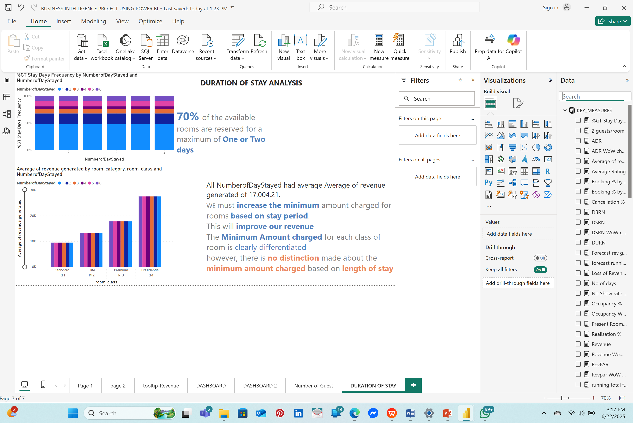

>CREATING DASHBOARD 5

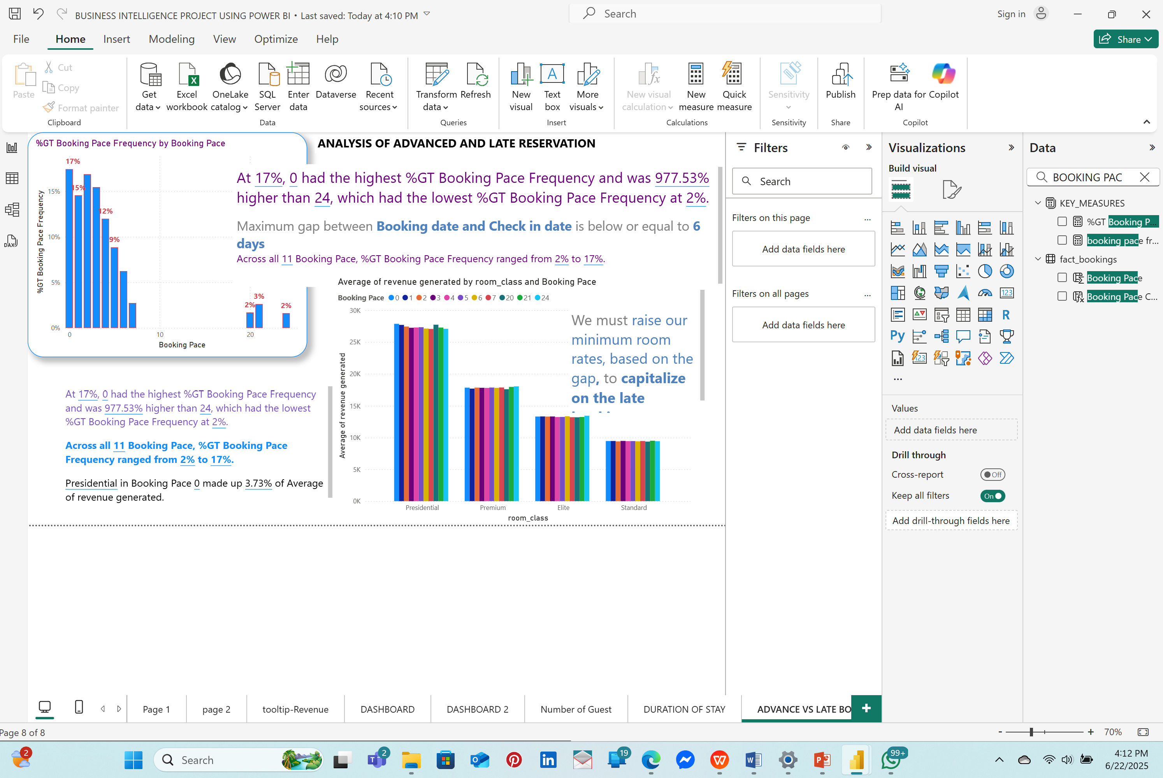

# 

# **3.0:CONCLUSION**

The AtliQ hospitality analytics project provided valuable insights into guest booking behavior and stay patterns across the business. By analyzing key dimensions such as number of days stayed, booking pace, and their corresponding frequencies and percentages, we were able to uncover trends that can inform operational and marketing strategies.

**3.1Key findings include:**

-Short stays (1–3 days) make up the majority of bookings, indicating a preference for quick getaways or business travel.A significant portion of bookings are made within 7 days of check-in, highlighting opportunities for last-minute promotions.

-The use of calculated fields such as “Booking Pace”, “Stay Days Frequency %”, and “2 guests/room” helped transform raw data into business-ready insights.

-Custom tables like sort_stay_days enabled accurate sorting and filtering for clear, interactive dashboards.

-Overall, this project has empowered stakeholders with data-driven visibility into guest behaviors, enabling more targeted decision-making around pricing, staffing, and marketing campaigns.